STORM WATER POLLUTION PREVENTION PLAN (SWPPP)
AND
IN-WATER POLLUTION PREVENTION PLAN (IWPPP)

Project Title: Hawaii Belt Road, Hakalau Stream Bridge
Rehabilitation, Bent #8 Scour Repair

Project No.: BR-019-2(082)

DA File No. POH-2022-00091
Prepared by: Department of Transportation, Highways Design Branch
Date: July 31, 2026

Storm Water Pollution Prevention Plan (SWPPP) and
In-Water Pollution Prevention Plan (IWPPP)
DA File No. POH-2022-00091
Preparation Date July 31, 2026

Table of Contents
Table of Contents 2
7.0 Preface 3
7.0.1 Notes for Contractor/HDOT Construction Personnel 4
7.2.1A (WQC Section 5) - Emergency Contacts 12
7.2.1 Storm Water Team 12
7.2.2A (WQC Section 1) - Army Corps Pre-Construction Notification 14
7.2.2 Nature of Construction Activities NOI Form C.6 15
7.2.2B (WQC Section 10 and Section 12) – Receiving State Water(s) Information 16
7.2.2C (WQC Section 12) – Project Scope 17
7.2.3 Emergency Related Projects 18
7.2.4 Identification of Prime Contractor and Other Site Contractors 19
7.2.5 Sequence and Estimated Dates of Construction Activities 20
7.2.6.1 Property Boundary Maps 21
7.2.6.1A (WQC Section 1) - Jurisdictional Waters of the U.S. (Army Corps Jurisdiction) Boundary Maps 22
7.2.6.2 to 7.2.6.8 State Waters and BMP Maps 23
7.2.7 Construction Site Pollutants 27
7.2.8 –Sources of Non-Storm Water 30
7.2.9 –Buffer Documentation 34
7.2.10 Storm Water Control Measures 35
Land Based BMP Details 36
In-Water BMP Details (WQC) 60
7.2.10.2 – Stabilization Practices 67
7.2.10.3 – Post Construction Measures 69
7.2.11.1 – Spill Prevention and Response Procedures 70
7.2.11.2 – Waste Management Procedures 71
7.2.12 – Procedures for Inspection, Maintenance, and Corrective Action for Land-Based Work Areas 71
7.2.12A (WQC) – Procedures for Inspection, Maintenance, and Corrective Action for In-Water Work Areas 73
7.2.12B (WQC) – Procedures for In-Water Work Areas During High Flow and Stop Work Conditions 76
7.2.13 – Staff Training 76
7.2.14 – Documentation of Compliance with Safe Drinking Water Act Underground Injection Control (UIC) Requirements for Certain Subsurface Storm Water Controls 77
7.2.15 –Other State, Federal, or County Permits 78
7.2.16 –Other Information As Requested by the Director 79
7.2.17 Certification of the CWB SWPPP/IWPPP 80
7.2.18 Post-Authorization Additions to the SWPPP/IWPPP 81
7.4 Required SWPPP/IWPPP Modifications 81
13.0 Monthly Compliance Report Submittal Requirements 82
SWPPP/IWPPP Attachments 83
Attachment A – Contractor/Sub-Contractor Control Maps, Property Boundary Maps, State Waters and BMP Maps, and BMP Details (SWPPP/IWPPP Sections 7.2.4, 7.2.6.1,7.2.6.2 to 7.2.6.8 & 7.2.10) 83
Attachment B – HDOT SWPPP/IWPPP Training Log (SWPPP/IWPPP Section 7.2.13) 84
Attachment C - Construction Schedule (SWPPP/IWPPP Section 7.2.5) 87
Attachment D – Subcontractor Certifications/Agreements (SWPPP/IWPPP Section 7.2.4) 89
Oahu Attachment E1 – SWPPP Inspection Report Form for Oahu Land-Based BMPS(SWPPP Section 7.2.12) Rev. 1/28/2015 91
Oahu Attachment E2 – Corrective Action Reports (SWPPP Section 7.2.12) Rev. 02/25/14 95
Oahu Attachment E3 – HDOT Highways Oahu Construction Discharge Response Flow Chart, Rev. 11/17/2015; HDOT Construction Discharge Report Form (SWPPP Section 7.2.12) Rev. 1/28/15 98
Oahu Attachment E4 – Monthly Compliance Report 105
Oahu Attachment E5 – Receiving State Waters Inspection Report for Individual NPDES Permits (SWPPP Section 7.2.12) Rev. 01/28/15 108
Kauai/Maui/Hawaii Attachment E1 – HDOT SWPPP Inspection Report for Kauai, Maui, and Big Island Land-Based BMPs 112
Statewide Attachment E6 – HDOT Inspection Report for In-Water Work (IWPPP Section 7.2.12A) 122
Attachment F – Spill Prevention and Response Procedures (SWPPP/IWPPP Section 7.2.11.1) 126
Attachment G – Waste Management Procedures (SWPPP/IWPPP Section 7.2.11.2) 131
Attachment H – Emergency Related Projects, Departures from Manufacturer’s Specifications for Fertilizers Containing Nitrogen or Phosphorus, Buffer Documentation, Documentation of Compliance with UIC Requirements, Other State/Federal/County Permits, Fugitive Dust Control Plan & Other Information as Requested by the Director (SWPPP/IWPPP Sections 7.2.3, 7.2.9, 7.2.14, 7.2.15, and 7.2.16) 138
Attachment J – Monthly Compliance Report 144
Attachment K – Post-Authorization Additions to the SWPPP/IWPPP (Including Army Corps PCN, 401 WQC, and Special Conditions) 145
Attachment L – SWPPP/IWPPP Modification Log 146

7.0 Preface
The following documents are referenced throughout the SWPPP/IWPPP:
- Hawaii Administrative Rules, Chapter 11-55
- HDOT Construction Best Management Practices Field Manual
- Hawaii Standard Specifications for Road and Bridge Construction dated 2005 and applicable special provisions.
- An Integrated Storm Water Management Approach and a Summary of Clear Water Diversion and Isolation Best Management Practices for Use in the State of Hawaii, by the Department of Transportation and Federal Highway Administration, Practitioners Guide (Practitioners Guide), April 2016 (Version 1, Draft)

7.0.1 Notes for Contractor/HDOT Construction Personnel

- Items in red need to be updated by the Contractor once the project is awarded prior to construction. The Contractor shall be responsible for updating the SWPPP/IWPPP during construction.

The Contractor shall implement or modify structural BMPs identified by designer in site plan. The Contractor shall design and implement the in water isolation and confinement BMPs for areas within the Army Corps Jurisdiction.

The Contractor shall keep an accurate account of the type(s) and estimated quantities (in cubic yards) of the BMPs placed and/or installed within the in-water work area (i.e. canal, stream, river), particularly any type of dredged and/or fill material (e.g., sand, soil, rock, gravel, concrete, etc.) discharged below the HTL/MHHW elevation used to divert flow/tidal waters away from in-water work areas, or to construct temporary access ramps, or for any other purpose in-water work areas.

NOTE: Currently, the project does not have an NPDES Permit to authorize discharges of storm water associated with construction activity.
The Contractor shall keep track of the total disturbed area. If the area is one acre or more, it will trigger an NPDES Permit.
Total Disturbed Area (including Staging Areas) = 0.8 Acres
Project Disturbed Area = 0.8 Acres
NOTE: The Staging Area is included in the 0.8 Acres. If the Contractor decides to use a Staging Area outside of the current Project Area and the Total Disturbed Area is one acre or more, then the Contractor is required to obtain an NPDES Form C Permit. All construction activity for this Project is in the water.

- Construction BMPs shall be inspected weekly, and within 24 hours of any rainfall event of 0.25 inches or greater in a 24 hour period and daily during periods of prolonged rainfall. For more details see Section 7.2.12 of this SWPPP/IWPPP.
- Immediately initiate and complete stabilization within 7 calendar days on areas of the site in which earth-disturbing activities have temporarily or permanently ceased. For more details see section 7.2.10.2 of the SWPPP/IWPPP.
Rain Gauge Location:
Time of Day the Rain Gauge will be checked each day: ______
Contractor Staging/Storage Areas
- The Contractor may use any disturbed area acceptable to the Engineer for Staging/Storage.
- Staging/Storage Areas outside disturbed areas or outside the project limits may require a new National Pollutant Discharge Elimination System (NPDES) Permit submittal. See permitting requirements in Section 209 of the Specifications and applicable Special Provisions.
The following applies to construction areas discharging to Hakalau Stream:
A variety of best management practices (BMPs) will be implemented to protect Waters of the U.S. from stormwater and non-stormwater related discharge or discharge from the construction site. In addition to the BMPs listed below, refer to BMPs identified in the Practitioners Guide. BMPs will be detailed in the storm water pollution prevention plan (SWPPP) and updated In-water pollution prevention plan (IWPPP) processes. These include:
- Comply with all requirements of the water quality standards in the Hawaii Administrative Rules (HAR), Chapter 11-54, and the Section 401 Water Quality Criteria (WQC) and all information submitted to the State of Hawaii Department of Health-Clean Water Branch (DOH-CWB) for compliance with the Notification and Reporting Requirements. Ensure that the activity will not result in non-compliance or violations to the applicable State WQS. Discharges associated with the proposed construction activities will be conducted in a manner that complies with "Basic Water Quality Criteria Applicable to All Waters" as specified in HAR, Chapter 11-54-4.
- Obtain NPDES permit for storm water discharges associated with construction activities when the proposed construction activities will disturb one (1) or more acres of land area before initiating any construction activities. (Note, currently an NPDES Form C Permit is not required for this project.)
- Apply best degree of treatment or control measures to the potential water pollutant discharges associated with the proposed construction activity(ies) that assures the discharges will meet requirements compatible with the basic water quality criteria applicable to all waters, uses and specific water quality criteria and recreational criteria established for the class of the receiving State waters. Best Management Practices (BMPs) shall be properly implemented and maintained during the entire construction period. Isolate and confine all in-water work areas throughout the entire water column (surface to bottom) such that all potential water pollutants will not leave or enter the work area. The entire volume of water in the in-water work area needs to be isolated and confined. Utilize BMPs that are inert and not themselves sources of pollution. (Examples of inappropriate in-water BMPs include, but are not limited to, compost biosocks since it is a source of nutrients; silt fence since the material is porous; and a soil berm since the soil particles will erode away). Ensure that all material(s) placed or to be placed in State waters are free of waste material, heavy metals, organic materials, debris and any water pollutants at toxic or potentially hazardous concentrations to aquatic life as specified in HAR 11-54-4(b).
- Deploy all BMPs around the perimeter of the project prior to the commencement of any construction work. These BMPs will be properly maintained throughout the entire period of in-water work and will not be removed until the in-water work is completed and the water quality in the in-water work area has returned to its pre-construction condition as demonstrated by the monitoring results (if applicable).
- Isolate and confine in-channel construction activities using a stream diversion method chosen by the contractor using the Practitioners Guide.
- Isolate and confine all upland activity to contain and retain water pollutants upland and not allow them to enter State waters, including the designated in-water work area. When it is necessary to conduct stream work, the workspace shall be isolated to avoid construction activities in flowing water in compliance with Practitioners Guide. The proposed project shall maintain aquatic organism passage (AOP) through the project area. Adequate water depth and channel width must be maintained at all times for passing design flood discharges. Prior to construction activities, isolate the workspace from flowing water to prevent sedimentation and turbidity and avoid impacts to aquatic organisms and water quality. The diversion or isolation BMPs shall remain in place during the life of the project and be removed immediately after work is completed in a manner that would allow flow to resume with the least disturbance to the substrate.
- For a stream, ditch, or gulch allow unimpeded flow around the isolated and confined in-water work area to allow for aquatic animal migration and/or to prevent downstream flooding situations. The unimpeded flow shall be equivalent to the 2-year 24-hour duration storm event and/or the existing flow capacity of the waterbody, whichever is smaller.
- Collect water pollutants from localized work areas and do not allow these water pollutants to enter or re-enter State waters, including the in-water work area. Examples of water pollutants include, but are not limited to, airborne particulate, dust, concrete slurry, concrete chips, concrete surface preparation washing effluent, construction debris, etc.
- Construction debris will be contained and prevented from entering or re-entering State waters. During bridge removal, construct structurally adequate debris shields to contain debris. Do not permit debris to enter waterways, travel lanes open to public traffic, or areas designated not to be disturbed. If portions of the existing bridge do fall into a stream during demolition, they will be removed from the stream without dragging the material along the streambed.
- Immediately cease construction work if water quality monitoring or daily inspection or observation results indicate that noncompliance to HAR, Chapter 11-54-4(a) or Chapter 11-54-4(b), will occur or is occurring. The construction activity shall not resume until adequate measures are implemented and appropriate corrective actions are taken and water quality monitoring demonstrates that the non-compliance has ceased. Note: These actions shall not preclude the DOH-CWB from taking enforcement action authorized by law.
- Do not disturb the area beyond the construction limits. Trees, shrubs or vegetated areas temporarily damaged by construction operations will be re-vegetated.
- Apply permanent soil stabilization as soon as practicable after final grading but no later than 14 days, or 7 days for impaired waters, after completion of earth disturbing activities.
- Apply turf establishment to finished slopes and ditches immediately but no later than 7 days after completion of earth disturbing activities.
- Provide certified weed free permanent and temporary erosion control measures to minimize erosion and sedimentation during and after construction according to the contract erosion control plan, contract permits, and Special Provision Sections 209, 619 and 641.
- Protect and care for seeded areas, including watering when needed until final acceptance. Repair all damages to seeded areas by reseeding, re-fertilizing and re-mulching.
- Ensure that all temporarily constructed structures, such as the silt containment device(s), floating oil and grease as well as construction debris containment device(s), berm, cofferdam, sheet pile, stream flow diversion structure(s), and/or sediment and soil erosion control structure(s), etc., are properly removed immediately after the completion of the construction work and when the affected water body has returned to its pre-construction condition or better, as demonstrated by the monitoring results, including color photographs.
- Ensure that the proposed construction activities related discharges not covered under the NWPs will also comply with State water pollution control permitting requirements under NPDES as established in HAR, Chapter 11-55.
- Pesticide application in State waters shall comply with HAR, §§11-54-4(a), 11-54-4(b), 11-54-4(c), 11-54-4(f) and/or Chapter 11-55, Appendix M - NPDES General Permit Authorizing Point Source Discharges from the Application of Pesticides.
- Ensure that no concrete truck wash water is disposed by percolation into the ground.
- Maintain and require all of their contractor(s) and the subcontractor(s) that are performing work covered under this Section 401 WQC, to maintain at the construction site or in the nearby field office, a copy of this letter, all Notification and Compliance Reporting Requirements, and all records demonstrating that every requirement of this Section 401 WQC has been complied with.
- Ensure that all areas temporarily impacted, either directly or indirectly, by the project construction activities are fully restored to their pre-construction conditions. For example: Incidental construction debris is cleaned up prior to removal of BMPs.
- Discontinue work during storm events or during flood conditions.
- Modify environmental protection measures, including BMPs and monitoring requirements, when instructed by the DOH-CWB for corrective action/remedial actions.
- Allow the DOH-CWB to conduct routine inspections of the construction site in accordance with Hawaii Revised Statutes (HRS) §342D-8.
- Complete and submit a Solid Waste Disclosure Form for Construction Sites to the DOH, Solid and Hazardous Waste Branch, Solid Waste Section. The form can be downloaded at: http://health.hawaii.gov/shwb/files/2013/06/swdiscformnov2008.pdf.
- Do not stockpile, store, or place construction material or construction activity-related materials in State waters or in ways that will disturb or adversely impact the aquatic environment.
- Dispose of construction debris, waste products, vegetation and/or dredged material removed from the construction site at upland State and County approved sites.
- Contain on land and not allow to enter or re-enter State waters any runoff, return flow, or airborne particulate pollutants, if any, from the excavated/dredged material dewatering process or from the stockpiling site.
- Ensure that their discharge activity shall not interfere with or become injurious to any designated uses (HAR, §11-54-1 and HAR, §11-54-3), or existing uses (HAR, § 11-54-1 and HAR, § 11-54-1 .1). The owner of the discharge shall maintain and protect all designated and existing uses.
- Do not discharge any effluent associated with the proposed construction activities, such as dewatering effluent, effluent resulting from hydroblasting, saw cutting, concrete surface preparation, rock washing, concrete and rock truck washing effluent or any other similar regulated activity(ies) shall be properly contained, collected and prevented from entering, either directly or indirectly, State waters, except for those discharges that have received authorization issued by the DOH-CWB under the NPDES Permit as applicable.
- Implement appropriate and effective measure(s) to properly contain/collect the potential water pollutant discharges resulting from the application of concrete corrosion inhibitor; or from the scrubbing, chipping, cutting, rebar reinforcing, grouting, filling activities needed for the permitted construction activity (ies).
- In Hawaii, the Commission on Water Resource Management (CWRM) issues permits regulating withdrawals of surface and groundwater. If water drafting is necessary, the Contractor will ensure this water use is approved in accordance with a stormwater use permit obtained from the CWRM (HRS §174C-48(1987)).
- Structures designed to minimize sediment and pollutant runoff from sensitive areas such vehicle and fuel storage areas, hazardous materials storage sites, and erosion control structures shall be visually monitored daily, especially following precipitation events to ensure these structures are functioning properly.
- Maintain temporary erosion control measures in working condition until the project is complete or the measures are no longer needed as outlined in Special Provision Section 209 and the SWPPP/IWPPP.
- For dewatering that may be required during excavation or construction of the project, a NPDES General Permit for Construction Activity Dewatering would be required for discharging dewatering effluent into waters of the US. The permit will require appropriate BMPs, an erosion control plan, and a water quality monitoring plan to mitigate any impacts on receiving waters.
- Develop a Rain Event Action Plan (REAP) prior to Notice to Proceed. The REAP will be reviewed and structured to address project specific actions that are needed to prevent pollutants from reaching the creeks and rivers during the rain event. The REAP will be executed within 48 hours prior to a forecast rain event of 50% chance of precipitation or more. BMPs in the REAP include:
  - When the trees are cleared, the slash will be chipped and placed as mulch on the area that has been cleared to prevent raindrop erosion.
  - Any area that has soil disturbances will be stabilized prior to rain events with mulch, wood chips, or other protective covers.
  - Sediment traps will be placed to collect the water and allow sediment to settle out. If sediment traps are not possible, other settling and filtering devices will be used to slow water down and remove sediments.
  - Operations will shut down during extreme rain events.
  - Fueling and repair areas will be covered and surrounded by a berm.
  - Exposed soil will be covered and stabilized.
  - Treated materials will be covered or placed in a shed.
  - Dumpsters will be covered at all times.
  - Drain holes will be plugged.
  - Control perimeters will be established around stockpiles of material.
- Submit a Spill Prevention, Control, and Countermeasure (SPCC) Plan with the Water Pollution, Dust, and Erosion Control Submittals.
- Any spill of petroleum products, hazardous materials, or other chemical or biological products released from stationary sources or construction, fleet, or other support vehicles shall be properly cleaned, mitigated, and remedied, if necessary. Any spill of petroleum products or a hazardous material shall be reported to the appropriate federal, state, and local authorities if the spill is a reportable quantity. Response shall occur in accordance with federal, state, and local regulations.
- In general, when gasoline, diesel fuel, antifreeze, hydraulic fluid or any other chemical contained within the vehicle is released to the pavement or the ground, proper, corrective, clean-up and safety actions specified in the SPCC and SWPPP will be immediately implemented. All vehicles with load rating of two tons or greater will carry, at minimum, enough absorbent materials to effectively immobilize the total volume of fluids contained within the vehicle.
- Repair leaks immediately on discovery. Equipment that leaks will not be used. Oil pans and absorbent material will be in place prior to beginning repair work. The contractor will be required to provide the “on-scene” capability of catching and absorbing leaks or spillage of petroleum products including antifreeze from breakdowns or repair actions with approved absorbent materials. A supply of acceptable absorbent materials at the job site in the vent of spills, as defined in the SWPPP will be available. Sand and soil are not approved absorbent materials. Soils contaminated with fluids will be removed, placed in appropriate safety containers, and disposed of according to state and/or federal regulations.
- Collect and dispose of all waste fuels, lubricating fluids, and other chemicals in a manner that ensures that no adverse environmental impact will occur. Construction equipment will be inspected daily to ensure hydraulic, fuel and lubrication systems are in good condition and free of leaks to prevent these materials from entering any stream. Vehicle servicing and refueling areas, fuel storage areas, and construction staging and materials storage areas will be sited a minimum of (50 feet) 15 meters from ordinary high water, typically referred to as the Q2 elevation, wetlands, and contained properly to ensure that spilled fluids or stored materials do not enter any stream or wetland.
- Attachment A shows the locations of sediment and erosion control features. The Contractor shall add additional BMPs to facilitate different phases of construction or to accommodate Contractor’s means and methods. These BMPs shall be tracked on the projects SWPPP/IWPPP.

7.2.1A (WQC Section 5) - Emergency Contacts
Provide the name and two (2) phone numbers of at least two persons who may be contacted in
case of emergency regarding “discharges” into the navigable waters. The Contractor shall include their personnel information once the project is awarded.

1) Name: Harry H. Takiue
Company: Hawaii Department of Transportation
Position: Hawaii District Engineer
Contact Number: (808) 933-8866 Contact Alternate (Cell) Phone number: (808) xxx-xxxx

2) Name: Contractor Representative
Company: Contractor
Position: Contractor
Contact Number: (808) XXX-XXXX Contact Alternate (Cell) Phone number: (808)xxx-xxxx

7.2.1 Storm Water Team

The permittee shall assemble and oversee a “storm water team,” which is responsible for the development of the SWPPP/IWPPP, any later modifications to it, and for compliance with the requirements in HAR 11-55.

The SWPPP/IWPPP must identify the personnel (by name or position) that are part of the storm water team, as well as their individual responsibilities. Each member of the storm water team must have ready access to an electronic or paper copy of applicable portions of this permit, the most updated copy of the SWPPP/IWPPP, and other relevant documents or information that must be kept with the SWPPP/IWPPP.
The Contractor shall include their personnel information once the project is awarded.
1) Name: Kevin Kasamoto
Company: Hawaii Department of Transportation
Position: HDOT Engineer
Contact Number: (808) 692-7563
Responsibilities: Develop SWPPP/IWPPP during the design process

2) Name: Allen Kam
Company: WSP USA, Inc.
Position: Design Consultant
Contact Number: (808) 566-2230
Responsibilities: Develop SWPPP/IWPPP during the design process

3) Name:
Company: Hawaii Department of Transportation
Position: HDOT Resident Engineer
Contact Number: (808) xxx-xxxx
Responsibilities: Authorized Representative’s delegatory signatory for BMP Inspection, Corrective Action, and Discharge Reports

4) Name:
Company: Hawaii Department of Transportation
Position: HDOT Construction Project Engineer
Contact Number: (808) xxx-xxxx
Responsibilities: Responsible for overall project and field compliance with permit conditions

5) Name:
Company: Hawaii Department of Transportation
Position: HDOT Construction Project Inspector
Contact Number: (808) xxx-xxxx
Responsibilities: Responsible for BMP inspections and verifying implementation of BMPs in the field

6) Name:
Company: Contractor
Position: Contractor Designated Representative
Contact Number: (808) xxx-xxxx
Responsibilities: Responsible for overall project and field compliance and BMP inspections

7) Name:
Company: Contractor
Position: Contractor
Contact Number: (808) xxx-xxxx
Responsibilities: Responsible to develop and maintain updates and modifications to the SWPPP

8) Name:
Company: Contractor
Position: Contractor
Contact Number: (808) xxx-xxxx
Responsibilities: Responsible for field compliance and BMP Inspection

7.2.2A (WQC Section 1) - Army Corps Pre-Construction Notification

Check all NWP or Federal Authorization Applicable for this project:
☑ NWP 3 - Maintenance
☐ NWP 5 – Scientific Measurement Devices
☐ NWP 6 – Survey Activities
☐ NWP 12 – Utility Line Activities
☐ NWP 13 – Bank Stabilization Activities
☐ NWP 14 – Linear Transportation Projects
☐ NWP 23 – Approved Categorical Exclusions
☐ NWP 33 – Temporary Construction Access and Dewatering
☐ Section 10 Rivers and Harbors Act Authorizations
☐ Individual 404 Permit Authorizations
☐ Other _____________________________

Are there any Special Conditions?
☐ Yes
☑ No

7.2.2 Nature of Construction Activities NOI Form C.6

What is the function of the construction activity (Please check all applicable activity(ies))?
☐ Residential ☐ Commercial ☐ Industrial ☐ Road Construction ☐ Linear Utility
☑ Other (please specify): Bridge Footing Repair
For construction site estimates, see Attachment A-1.3

What is being constructed? Proposed in-water repair and maintenance work will consist of the following activities to stabilize the downstream Bent #8 footing:
•Removal of loose material under the existing footing;
•Grouting of the void under the existing footing, including construction of a temporary containment device in the water; and
•Sediment containment, removal, and disposal.

Describe the scope of work and major construction activities covered in this NOI, including baseyards and staging areas. Include only project areas where the locations of impervious structures are known; project areas where the final grades are known; and work areas that will be performed by one (1) general contractor. A separate NOI will be required for all other project areas. (Note: Per Section 209 of the specifications and applicable special provisions, the maximum surface area of earth material which may be exposed at any time is 300,000 square feet.)
Construction activities at Bent #8 will include removal of loose material under the existing footing; grouting of the void under the existing footing, including construction of a temporary containment device in the water; and sediment containment, removal, and disposal. All work and construction staging areas, including foot access areas, will be contained to the roadway right-of-way (ROW) area under the bridge and along an existing privately owned access road. The locations of the staging and storage areas may be changed by the Contractor depending on his construction means and methods. The Contractor shall submit to the Engineer the locations of his staging and storage areas once the project is awarded for review and acceptance.

7.2.2B (WQC Section 10 and Section 12) – Receiving State Water(s) Information
  - Identify the receiving State water which the project will be conducted in. The receiving State water must be a surface water.

Latitude: 19°53’58”N Longitude: 155°07’47”W

Receiving Water Name: Hakalau Stream

Receiving State Waters Classification: Class 2, Inland

Is the receiving State Water on the Section 303(d) List?:
 Yes  No

If the Receiving Water is on the Section 303(d) List, provide the impairment pollutants:
Total nitrogen (TN), nitrate+nitrite as nitrogen (NO₃+NO₂), total phosphorus (TP), and turbidity

  - Provide the Outfall coordinates of any outfalls for work outside of the Army Corps 404 Permit/Section 10 Rivers and Harbors Act Authorization. Indicate if the Receiving State Water is on the Section 303(d) list and the impairment pollutants if any.
All work is within the Corps Jurisdiction. Discharge Point shown on Attachment A-3.

1) Discharge Point Label: Discharge Point #1 (from)
Latitude: 19°53’55.36”N Longitude: 155°07’52.19”W

Receiving Water Name: Hakalau Stream

Receiving State Waters Classification: Class 2, Inland

Is the receiving State Water on the Section 303(d) List?:
 Yes  No

2) Discharge Point Label: Discharge Point #1 (to)
Latitude: 19°53’58.69”N Longitude: 155°07’46.89”W

Receiving Water Name: Hakalau Stream

Receiving State Waters Classification: Class 2, Inland

Is the receiving State Water on the Section 303(d) List?:
 Yes  No

If the Receiving Water is on the Section 303(d) List, provide the impairment pollutants:
Total nitrogen (TN), nitrate+nitrite as nitrogen (NO₃+NO₂), total phosphorus (TP), and turbidity

 The Topographic Map showing the Locations of the Outfalls is included in Attachment A

7.2.2C (WQC Section 12) – Project Scope

Describe the overall project scope and activities.
a. The overall project description should include: the project activities both in and out of the navigable waters, the construction or operation of facilities which may result in any direct and/or indirect “discharges” into State waters.

Hakalau Bridge is a 14-span steel trestle bridge, consisting of a concrete deck slab supported on four steel plate girders. The girders span between steel towers and bents, which are supported by concrete pedestals on concrete foundations. The tower on the Honokaa (north) bank of the stream comprises of Bents #8 and #9. The foundations for Bents #8 and #9 consist of 10-foot diameter cylindrical concrete spread footings.

A March 2021 bridge inspection identified approximately seven (7) inches of scour depth beneath one (1) footing at the downstream end of Bent #8. The purpose of this project is to provide an expedited repair of the scour damage to the bridge foundation beneath Bent #8, in order for the bridge to remain fully functional until a future bridge rehabilitation project addresses more permanent repairs to the trestle bridge towers and footings.

Proposed in-water repair and maintenance work will consist of the following activities to stabilize the downstream Bent #8 footing:
• Removal of loose material under the existing footing;
• Grouting of the void under the existing footing, including construction of a temporary containment device in the water; and
• Sediment containment, removal, and disposal.

The area around Hakalau Stream Bridge has a known lead contamination issue stemming from previous lead paint removal and repainting of the bridge throughout the years. Remediation of the lead contamination is part of a future bridge rehabilitation project that is currently under design. The current project will only focus on repairing the scour at Bent #8 which will allow the bridge to remain open and fully functional until the future bridge rehabilitation project addresses the lead contamination and more permanent repairs to the trestle bridge support structure. Based on several years of testing in preparation for the future bridge rehabilitation project, the lead contamination surrounding the bridge appears to be confined to the land (stream bank) on either side of the bridge. No lead contamination is believed to remain in the stream itself, as any lead which previously entered the water below the bridge is assumed to have been transported downstream and away from the project site. The Construction Environmental Hazard Management Plan (C-EHMP) for the project is attached to the SWPPP/IWPPP in Attachment H.

The proposed work will not involve railing repairs, roadway resurface repairs, or other roadway or bridge improvements, such as signage or guardrails. The project does not propose to widen the bridge footprint or superstructure. All work and construction staging areas, including foot access areas, will be contained to the roadway right-of-way (ROW) area under the bridge and along an existing privately owned access road. Although a portion of the access road is included in the project area, no actual work will be conducted on the roadway or paved areas, as all work will be conducted in the water. No construction equipment will be staged in the stream.

7.2.3 Emergency Related Projects
Note: This Section is only applicable to Construction Activities NPDES/NGPC Permits
 Not Applicable
☐ Applicable (If this box is checked, provide additional information as described below)
If conducting earth-disturbing activities in response to a public emergency (see section 1.3.), the permittee shall document the cause of the public emergency (e.g., natural disaster, extreme flooding conditions, etc.), information substantiating its occurrence (e.g., state disaster declaration or similar state declaration), and a description of the construction necessary to reestablish effected public services. The declaration of emergency or imminent threat to public health is required to be from the state governor or the director. See Attachment H for additional information.

7.2.4 Identification of Prime Contractor and Other Site Contractors
The SWPPP/IWPPP must include a list of both the prime contractor and all other contractors (e.g., sub-contractors) who will be engaged in construction activities at the site, and the areas of the site over which each contractor has control. List prime contractor and sub-contractors below and attach map showing areas of control in Attachment A. Complete and attach a Subcontractor Certification/Agreement in Attachment D.
(General Contractor Company Name) The general contractor information will be submitted at least 30 calendar days before the start of construction activities.
(General Contractor Contact Person Name)
(General Contractor Mailing Address)
(General Contractor Mailing City) | (General Contractor Mailing State and Zip Code)
(General Contractor Telephone Number)
(General Contractor Email Address)

(Sub-Contractor #1 Company Name, as needed)
(Sub-Contractor Contact Person Name)
(Sub-Contractor Mailing Address)
(Sub-Contractor Mailing City) | (Sub-Contractor Mailing State and Zip Code)
(Sub-Contractor Telephone Number)
(Sub-Contractor Email Address)

(Sub-Contractor #2 Company Name, as needed)
(Sub-Contractor Contact Person Name)
(Sub-Contractor Mailing Address)
(Sub-Contractor Mailing City) | (Sub-Contractor Mailing State and Zip Code)
(Sub-Contractor Telephone Number)
(Sub-Contractor Email Address)

(Sub-Contractor #3 Company Name, as needed)
(Sub-Contractor Contact Person Name)
(Sub-Contractor Mailing Address)
(Sub-Contractor Mailing City) | (Sub-Contractor Mailing State and Zip Code)
(Sub-Contractor Telephone Number)
(Sub-Contractor Email Address)

❑ Attach maps showing areas of Contractor/Subcontractor Control in Attachment A.

❑ Complete and attach a Subcontractor Certification/Agreement in Attachment D.

7.2.5 Sequence and Estimated Dates of Construction Activities

Separate the schedule for In-Water and Land-Based work. In Attachment C, attach the proposed construction schedule which shall include, at a minimum:
The Contractor shall submit to the Engineer an update of the dates once the project is awarded for inclusion in the SWPPP/IWPPP.

Land Based (HAR 11-55)
 Installation of storm water control measures, and when they will be made operational, including an explanation of how the sequence and schedule for installation of storm water control measures complies with section 5.1.1.3.1. and of any departures from manufacturer specifications pursuant to section 5.1.1.3.2., including removal procedures of the storm water control measures after construction has ceased.

☐ Commencement and duration of earth-disturbing activities, including clearing and grubbing, mass grading, site preparation (i.e., excavating, cutting and filling), final grading, and creation of soil and vegetation stockpiles requiring stabilization.

☐ Cessation, temporarily or permanently, of construction activities on the site, or in designated portions of the site.

☐ Final or temporary stabilization of areas of exposed soil. The dates for stabilization must reflect the applicable deadlines to which the permittee is subject to in section 5.2.1.

 Removal of temporary storm water conveyances/channels and other storm water control measures, removal of construction equipment and vehicles, and cessation of any pollutant-generating activities.

In-Water (CWA Section 404 and Section 401 WQC and HAR 11-54)
 Date BMP measures to isolate and contain work areas are installed.

 Commencement and duration of In-Water construction activities.

 Cessation, temporarily or permanently, of construction activities on the site, or in designated portions of the site.

 Removal of temporary storm water conveyances/channels and other storm water control measures, removal of construction equipment and vehicles, and cessation of any pollutant-generating activities.

7.2.6.1 Property Boundary Maps
Boundaries of the property and of the locations where construction activities will occur. Attach, title, and identify all maps (pdf - minimum 300 dpi) listed below, in Attachment A.
- Legal boundaries of the project. See Attachment A-2 Legal Boundaries
- Locations where earth-disturbing activities will occur, noting any sequencing of construction activities See Attachment A-1.3, Plan Sheet EC-2.
- Pre-Construction Topography including approximate slopes and drainage patterns for the entire Facility/Project site to the receiving storm water drainage system (if applicable) or to the receiving State water(s) (with flow arrows). Note areas of steep slopes (15% or greater in grade). See Attachment A-1.3, Plan Sheet EC-2.
- During-Construction Topography (after major grading activities) including approximate slopes and drainage patterns for the entire Facility/Project site to the receiving storm water drainage system (if applicable) or to the receiving State water(s) (with flow arrows) Note areas of steep slopes (15% or greater in grade). N/A There will be no changes to topography.
- Post-Construction Topography including approximate slopes and drainage patterns for the entire Facility/Project site to the receiving storm water drainage system (if applicable) or to the receiving State water(s) (with flow arrows). Note areas of steep slopes (15% or greater in grade). N/A There will be no changes to topography.
- Locations where sediment, soil, or other construction materials will be stockpiled 7.2.6.1c.
See Attachment A-1.3. Stockpile locations may be changed by the Contractor depending on his construction means and methods. The Contractor shall submit to the Engineer for his review and acceptance the locations of stockpiles once the project is awarded and will be included in the SWPPP/IWPPP. The Contractor shall submit to the Engineer for his review and acceptance any updates/changes to stockpile areas during construction for inclusion in the SWPPP/IWPPP.
- Locations of any contaminated soil or contaminated soil stockpiles 7.2.6.1d. Location of lead contamination is shown on the figure Decision Units and Previous Sample Results included with the C-EHMP in Attachment H. Note that remediation of this lead is covered in another HDOT project.
- Locations of any crossings of state waters 7.2.6.1e. See Attachment A-1.1 for the location of Hakalau Stream.
- Designated points on the site where vehicles will exit onto paved roads 7.2.6.1f. See Attachment A-1.3, Plan Sheet EC-2. Stabilized entrance locations may be changed by the Contractor depending on his construction means and methods. The Contractor shall submit to the Engineer the locations of stabilized entrances once the project is awarded for his review and acceptance and will be included in the SWPPP/IWPPP. The Contractor shall submit to the Engineer for his review and acceptance any updates/changes to stabilized entrances during construction for inclusion in the SWPPP/IWPPP.
- Location(s) of impervious structures (including buildings, roads, parking lots, etc.) after construction is completed 7.2.6.1g. No change as to the location of impervious structures.
- Locations of construction support activity areas covered by this permit 7.2.6.1h. See Attachment A-1.3, Plan Sheet EC-2. The locations of the staging and storage areas may be changed by the Contractor depending on his construction means and methods. The Contractor shall submit to the Engineer the locations of his staging and storage areas for his review and acceptance once the project is awarded. The Contractor shall submit to the Engineer any updates/changes to staging and storage areas during construction for his review and acceptance and inclusion in the SWPPP/IWPPP.

7.2.6.1A (WQC Section 1) - Jurisdictional Waters of the U.S. (Army Corps Jurisdiction) Boundary Maps
Boundaries of the property and of the locations where construction activities will occur. Attach, title, and identify all maps (pdf - minimum 300 dpi) listed below, in Attachment A.
- Map showing the Jurisdiction Line between In-Water and Land Based BMPs See Attachment A-1.3, Plan Sheet EC-2, showing location of In-Water and Land-Based BMPs and Temporary Impact Area
Prior to commencement of the authorized work in wetlands, other special aquatic sites and other waters, the Contractor shall clearly identify (demarcate) in the field, the geographic limits of such waters (i.e., High Tide Line, Mean High Water Mark, Ordinary High Water Mark, approved wetland boundary) affected by the authorized work and as approved by the Army Corps and demarcated above. The delineation of these geographic bounds shall be accomplished by staking, flagging, painting, silt fencing, signage, buoys, etc. and in all cases shall be maintained and remain observable throughout the construction period. The Contractor shall also demarcate in the field the project limits of the Corps-authorized fill footprint to ensure that dredged or fill material is not discharged beyond the authorized limits. The permittee is prohibited from conducting any activity occurring in or affecting wetlands, other special aquatic sites and other waters that requires prior authorization from the Corps, outside of the permitted limits of disturbance (as shown on the permit drawings).

7.2.6.2 to 7.2.6.8 State Waters and BMP Maps

Attach, title, and identify all maps (pdf - minimum 300 dpi) listed below, in Attachment A.
Please reference which maps account for the features listed below.
- Locations of all state waters, including wetlands, that exist within or in the immediate vicinity of the site and indicate which waterbodies are listed as impaired 7.2.6.2. See Attachment A-1.1. Hakalau Stream is impaired for total nitrogen (TN), nitrate+nitrite as nitrogen (NO3+NO2), total phosphorous (TP), and turbidity.
- The boundary lines of any natural buffers provided consistent with section 5.1.2.1.1, 7.2.6.3.
N/A
- Topography of the site, existing vegetative cover (e.g., forest, pasture, pavement, structures), and drainage pattern(s) of storm water onto, over, and from the site property before and after major grading activities 7.2.6.4. See Attachment A-1.3, Plan Sheet EC-2. There are no grading activities.
- Storm water discharge locations, including: a) Locations of any storm drain inlets on the site and in the immediate vicinity of the site to receive storm water runoff from the project; No storm drain inlets on the site or in the immediate vicinity of the site.
and b) Locations where storm water will be discharged to state waters (including wetlands)7.2.6.5. No stormwater discharge facilities are associated with the project.

- Locations of all potential pollutant-generating activities identified in section 7.2.7, 7.2.6.6.
See Attachment A-1.3, Plan Sheet EC-2, and see Attachment H for the Decision Units and Previous Sample Results Figure. Note that lead remediation is part of another contract.
- Locations of storm water control measures 7.2.6.7. See Attachment A-1.3, Plan Sheet EC-2. The Contractor may change the locations of storm water control measures by construction activity and construction sequence depending on his construction means and methods. The Contractor shall submit changes to the Engineer for his review and acceptance once the project is awarded. The Contractor shall submit a separate map for each phase of construction which changes the drainage pattern. The Contractor shall submit to the Engineer for his review and acceptance any updates/changes to storm water control measures during construction for inclusion in the SWPPP/IWPPP.
- Locations where chemicals will be used and stored 7.2.6.8. For locations where chemicals will be used, see Attachment A-1.3 Plan Sheet EC-2. The table below shows possible chemicals which may be used on site and which construction activity they are associated with. The locations where chemicals may be used and stored may be changed by the Contractor depending on his construction means and methods. The Contractor shall submit to the Engineer for his review and acceptance any updates/changes to locations where chemicals will be used and stored during construction for inclusion in the SWPPP/IWPPP.
Chemical | Location | Major Construction Activity
Hydraulic oils/ fluids  * Applicable As Noted or Not Applicable (If no indication, then all are Applicable)  [If all of the items listed in the middle column are applicable, delete the highlighted text above. If some items are not applicable, leave « *Applicable As Noted ». If everything is not applicable, leave « *Not Applicable »] | - Vehicle Refueling area  - Leaks from broken hoses on equipment  - Vehicles shall be maintained off site. If a maintenance area is necessary on-site, the Contractor shall submit to the Engineer the locations and BMPs for his review and acceptance for inclusion in the SWPPP/IWPPP.  [If an item is not applicable, write “Not Applicable” in bold, un-italicized text after the item and also include a brief explanation why it is not applicable. Delete all text in this column if it is Not Applicable] | Bridge Footing Repair  [Edit as applicable. Delete all text in this column if Not Applicable.]
Antifreeze/Coolants  * Applicable As Noted or Not Applicable (If no indication, then all are Applicable) | - Vehicle Refueling area  - Leaks from broken hoses on equipment  - Vehicles shall be maintained off site. If a maintenance area is necessary on-site, the Contractor shall submit to the Engineer the locations and BMPs for his review and acceptance for inclusion in the SWPPP/IWPPP. | Bridge Footing Repair
Concrete Curing Compounds/ Form Release Oils  * Applicable As Noted or Not Applicable (If no indication, then all are Applicable) | - Grouting of the void under the existing footing | Bridge Footing Repair
Pesticides  * Applicable As Noted or Not Applicable (If no indication, then all are Applicable) | - Landscaping areas | Landscaping
Herbicides  * Applicable As Noted or Not Applicable (If no indication, then all are Applicable) | - Landscaping areas | Landscaping
Insecticides  * Applicable As Noted or Not Applicable (If no indication, then all are Applicable) | - Landscaping areas | Landscaping
Fertilizers  * Applicable As Noted or Not Applicable (If no indication, then all are Applicable) | - Landscaping areas | Landscaping

7.2.7 Construction Site Pollutants

For each pollutant-generating activity, an inventory of pollutants or pollutant constituents (e.g., sediment, fertilizers and/or pesticides, paints, solvents, fuels) associated with that activity, which could be exposed to rainfall and could be discharged from the construction site. The Contractor shall take into account where potential spills and leaks could occur that contribute pollutants to storm water discharges. The Contractor shall also document for the Engineer’s review and acceptance any departures from the manufacturer’s specifications for applying fertilizers containing nitrogen and phosphorus, as required in Section 5.3.5.1 under Attachment H.
All solid waste shall be disposed of at DOH, Solid and Hazardous Waste Branch (SHWB), Solid Waste Section (SWS) permitted facilities. If not, contact the SHWB-SWS at (808) 586-4226 as additional permits may be required.

Source/Material | Description of How Potential Pollutant Source will be Prevented from Discharging with  Storm Water Runoff | Major Construction Activity
Construction debris, green waste, general litter  * Not Applicable (If no indication, then Applicable)  [If the item in the middle column is applicable, delete the highlighted text above. If the item is not applicable, leave « *Not Applicable »] | - See Section 7.2.10 for Site Specific BMPs  [If this is not applicable, write a brief explanation why it is not applicable in bold, un-italicized text.] | Bridge Footing Repair  [Edit as applicable, not limited to above. Delete all text in this column if Not Applicable.]
Materials associated with the operation and maintenance of equipment, such as oil, fuel, and hydraulic fluid leakage  * Not Applicable (If no indication, then Applicable) | - See Section 7.2.10 for Site Specific BMPs | Bridge Footing Repair
Soil erosion from the disturbed areas  * Not Applicable (If no indication, then Applicable) | - See Section 7.2.10 for Site Specific BMPs | Bridge Footing Repair
Sediment from soil stockpiles  * Not Applicable (If no indication, then Applicable) | - See Section 7.2.10 for Site Specific BMPs | Bridge Footing Repair
Emulsified asphalt or prime/tack coat  * Not Applicable (If no indication, then Applicable) | - See Section 7.2.10 for Site Specific BMPs | Bridge Footing Repair
Materials associated with painting, such as paint and paint wash solvent  * Not Applicable (If no indication, then Applicable) | - See Section 7.2.10 for Site Specific BMPs | Bridge Footing Repair
Industrial chemicals, fertilizers, and/or pesticides  * Not Applicable (If no indication, then Applicable) | - See Section 7.2.10 for Site Specific BMPs | Bridge Footing Repair
Hazardous waste (Batteries, Solvents, Treated Lumber, etc.)  * Not Applicable (If no indication, then Applicable) | - See Section 7.2.10 for Site Specific BMPs | Bridge Footing Repair
Metals and Building Materials  * Not Applicable (If no indication, then Applicable) | - See Section 7.2.10 for Site Specific BMPs | Bridge Footing Repair
Existing Pollution Sources  * Not Applicable (If no indication, then Applicable) | - See Section 7.2.10 for Site Specific BMPs | Bridge Footing Repair
Other (Contaminated Soil)  * Not Applicable (If no indication, then Applicable) | - See Section 7.2.10 for Site Specific BMPs | Bridge Footing Repair

7.2.8 –Sources of Non-Storm Water
The SWPPP/IWPPP must also identify all sources of non-storm water and information, including, but not limited to, the design, installation, and maintenance of the control measures to prevent its discharge.
All solid waste shall be disposed of at DOH, Solid and Hazardous Waste Branch (SHWB), Solid Waste Section (SWS) permitted facilities. If not, the Contractor shall contact the SHWB-SWS at (808) 586-4226 and notify the Engineer for his agreement the disposal locations. Additional permits may be required.

Source | Description of How Potential Non-Storm Water Pollution Source will not be Discharged to State Waters | Major Construction Activity
Dust Control Water  * Not Applicable (If no indication, then Applicable)  [If the item in the middle column is applicable, delete the highlighted text above. If the item is not applicable, leave « *Not Applicable »] | - See Section 7.2.10 for Site Specific BMPs  [If this is not applicable, write a brief explanation why it is not applicable in bold, un-italicized text.] | Bridge Footing Repair  [Edit as applicable. Delete all text in this column if Not Applicable.]
Concrete Truck Wash Water  *Not Applicable (If no indication, then Applicable) | - See Section 7.2.10 for Site Specific BMPs | Bridge Footing Repair
Sediment Track Out  *Not Applicable (If no indication, then Applicable) | - See Section 7.2.10 for Site Specific BMPs | Bridge Footing Repair
Irrigation Water  *Not Applicable (If no indication, then Applicable) | - See Section 7.2.10 for Site Specific BMPs | Bridge Footing Repair
Hydrotesting Effluent  *Not Applicable (If no indication, then Applicable) | - See Section 7.2.10 for Site Specific BMPs | Bridge Footing Repair
Dewatering Effluent  *Not Applicable (If no indication, then Applicable) | - See Section 7.2.10 for Site Specific BMPs | Bridge Footing Repair
Saw-cutting Slurry  *Not Applicable (If no indication, then Applicable) | - See Section 7.2.10 for Site Specific BMPs | Bridge Footing Repair
Concrete Curing Water  *Not Applicable (If no indication, then Applicable) | - See Section 7.2.10 for Site Specific BMPs | Bridge Footing Repair
Plaster Waste Water  *Not Applicable (If no indication, then Applicable) | - See Section 7.2.10 for Site Specific BMPs | Bridge Footing Repair
Water-Jet Wash Water  *Not Applicable (If no indication, then Applicable) | - See Section 7.2.10 for Site Specific BMPs | Bridge Footing Repair
Sanitary/Septic Waste  *Not Applicable (If no indication, then Applicable) | - See Section 7.2.10 for Site Specific BMPs | Bridge Footing Repair

7.2.9 –Buffer Documentation

If required to comply with section 5.1.2.1. because a state water is located within 50 feet of the project’s earth disturbances, describe which compliance alternative has been selected for the site, and comply with any additional requirements to provide documentation in Section 5.1.2.1. Delineate, and clearly mark off, with flags, tape, or other similar marking device all natural buffer areas. Use velocity dissipation devices if necessary to prevent erosion caused by storm water within the buffer. Ensure all discharges are first treated by erosion and sediment controls.
Note: Buffer compliance requirements must be maintained until construction on the area discharging to the buffer is complete, and the area is restored and stabilized (as applicable).

☐ Option 1
Provide and maintain a 50-foot undisturbed natural buffer and sediment control.
Note: If the earth disturbances are located 50 feet or further from a state water and have installed sediment control, then the permittee has complied with this alternative. If the buffer is located outside State Highways Right of Way, include written permission from the owner of the land in SWPPP/IWPPP Attachment H.

Width of Buffer feet

☐ Option 2
Provide and maintain an undisturbed natural buffer that is less than 50 feet and double sediment control (e.g., double perimeter control) spaced a minimum of 5 feet apart.

Width of Buffer feet

☐ Option 3
If it is infeasible to provide and maintain an undisturbed natural buffer of any size, the permittee shall provide and maintain double sediment control (e.g., perimeter control) spaced a minimum of 5 feet apart and complete stabilization within 7 calendar days of the temporary or permanent cessation of earth-disturbing activities. Provide documentation why it is infeasible to provide buffer of any size in Attachment H.

☐ Exception 1
There is no discharge of storm water to state waters through the area between the site and any state waters located within 50 feet of the site, the permittee is not required to comply with the requirements in this section. This includes situations where control measures have been implemented, such as a berm or other barrier, that will prevent such discharges.

◻ Exception 2
For “linear construction projects” where “linear construction projects” means the construction of roads, bridges, conduits, substructures, pipelines, sewer lines, towers, poles, cables, wires, connectors, switching, regulating and transforming equipment and associated ancillary facilities in a long, narrow area, the permittee is not required to comply with the requirements in this section if site constraints (e.g., limited right-of-way) prevent the permittee from meeting any of the compliance alternatives in section 5.1.2.1.1., provided that, to the extent practicable, the permittee limit disturbances within 50 feet of state waters and/or the permittee provide erosion and sediment controls to treat storm water discharges from earth disturbances within 50 feet of the state water. The permittee shall also document below the rationale as to why it is infeasible to comply with the requirements in section 5.1.2.1.1., and describe any buffer width retained and/or erosion and sediment controls installed below.

 Exception 3
The following disturbances within 50 feet of a state water are exempt from the requirements in this Part: construction approved under a CWA 404 permit; or construction of a water-dependent structure or water access area (e.g., pier, boat ramp, trail).
The construction work is covered under an Army Corps 404 Permit.

The permittee shall document in the SWPPP/IWPPP if any of the above disturbances will occur within the buffer area on the site below.
N/A

7.2.10 Storm Water Control Measures
Please refer to Hawaii Department of Transportation Construction Best Management Practices Field Manual dated January 2008 and Supplemental Sheets. For any conflicting requirements between the Manual and applicable bid documents, the applicable bid documents will govern. Should a requirement not be clearly described within the applicable bid documents, the Contractor shall notify the Engineer immediately for interpretation. For the purposes of clarification under “applicable bid documents” include the construction plans, standard specifications, Special Provisions, Permits, and the SWPPP/IWPPP.

Land Based BMP Details
Complete the table below. Note: Bold text in the table are requirements of HAR 11-55. The Contractor shall include the specific product sheets (e.g. Tru-Dam or Gutter Buddy, etc.) and any changes to the proposed BMPs above for the Engineer’s review and acceptance.
Check the appropriate boxes below verifying the following requirements are met. If not applicable indicate on the blank lines below (7.2.10.1):

☐ The specific perimeter sediment controls will be installed and made operational prior to conducting earth-disturbing activities in any given portion of the site that will receive storm water from earth-disturbing activities are described below (7.2.10.1b). There are no earth moving activities.

 If contaminated soil exists on-site, control measures will be taken to either prevent the contact of storm water with the contaminated soil, including any contaminated soil stockpiles, or prevent the discharge of any storm water runoff which has contacted contaminated soil or any contaminated soil stockpiles are described below (7.210.1.c). The area around Hakalau Stream Bridge has a known lead contamination issue stemming from previous lead paint removal and repainting of the bridge throughout the years. Remediation of the lead contamination is part of a future bridge rehabilitation project that is currently under design. The current project will only focus on repairing the scour at Bent #8 which will allow the bridge to remain open and fully functional until the future bridge rehabilitation project addresses the lead contamination and more permanent repairs to the trestle bridge support structure. Based on several years of testing in preparation for the future bridge rehabilitation project, the lead contamination surrounding the bridge appears to be confined to the land (stream bank) on either side of the bridge. No lead contamination is believed to remain in the stream itself, as any lead which previously entered the water below the bridge is assumed to have been transported downstream and away from the project site. The Contractor shall add the BMP measures and locations if any contamination is found on-site for the Engineer’s review and acceptance.

 For exit points on the site (or any areas which exit onto a paved street), stabilization techniques and any additional controls that are planned to remove sediment prior to vehicle exit consistent with Section 5.1.2.3 will be taken and are described below (7.2.10.1d). Stabilized entrance locations may be changed by the Contractor depending on his construction means and methods. The Contractor shall submit to the Engineer for his review and acceptance the locations of stabilized entrances once the project is awarded for inclusion in the SWPPP/IWPPP. The Contractor shall submit to the Engineer for his review and acceptance any updates/changes to stabilized entrances during construction for inclusion in the SWPPP/IWPPP.

☐The project is linear, and the use of perimeter controls on portions of the site is impracticable for the following reasons (7.2.10.1e):

Pollutant Source | Appropriate Site-Specific BMP to be Implemented | BMP Requirements
Construction debris, green waste, general litter | - Separate contaminated clean up materials from construction and demolition (C&D) wastes.  - Provide waste containers (e.g., dumpster or trash receptacle) of sufficient size and number to contain construction and domestic wastes.  - Inspect construction waste and recycling areas regularly.  - Schedule solid waste collection regularly.  - Schedule recycling activities based on construction/demolition phases.  - Empty waste containers weekly or when they are two-thirds full, whichever is sooner.  - Do not allow containers to overflow. Clean up immediately if they do.  - On work days, clean up and dispose of waste in designated waste containers.  - See Solid Waste Management Section SM-6 for additional requirements.  - Provide Storm Drain Inlet Protection and/or Perimeter Sediment Controls as applicable.  - Collect and dispose of all waste materials in trash dumpsters. Place dumpsters, with secure watertight lids, away from storm water conveyances and drains, in a covered  - materials storage area.  - Dispose of construction and non- construction solid waste in accordance with State DOH regs.  - Load removed non- recyclable vegetation directly onto trucks; cover and transport to a licensed facility | See Solid Waste Management Section SM-6. Protect Storm Drain Inlets SC-1, and Perimeter Sediment Controls where applicable.  See Litter Management Plan.
Materials associated with the operation and maintenance of equipment, such as oil, fuel, and hydraulic fluid leakage | - Use off-site wash racks, repair and maintenance facilities, and fueling sites when practical.  - Designate bermed wash area if cleaning on site is necessary.  - Place drip pans or drop cloths under vehicles and equipment to absorb spills or leaks.  - Provide an ample supply of readily available spill cleanup materials.  - Clean up spills immediately, using dry clean-up methods where possible, and dispose of used materials properly.  - Do not clean surfaces or spills by hosing the area down.  - Eliminate the source of the spill to prevent a discharge or a continuation of an ongoing discharge.  - Inspect on-site vehicles and equipment regularly and immediately repair leaks.  - Regularly inspect fueling areas and storage tanks.  - Train employees on proper maintenance and spill practices and procedures and fueling and cleanup procedures.  - Store diesel fuel, oil, hydraulic fluid, or other petroleum products or other chemicals in water-tight containers and provide cover or secondary containment.  - Do not remove original product labels and comply with manufacturer’s labels for proper disposal.  - Dispose of containers only after all the product has been used.  - Dispose of or recycle oil or oily wastes according to Federal, State, and Local requirements.  - Store soaps, detergents, or solvents under cover or other means to prevent contact with rainwater.  - See Vehicle and Equipment Cleaning, Maintenance, and Refueling, Sections SM-11, SM-12, and SM-13 and Material Storage and Handling SM-2 for additional requirements. | See Vehicle and Equipment Cleaning, Maintenance, and Refueling, Sections SM-11, SM-12, and SM-13, and Material Storage and Handling Section SM-2, and Spill Prevention and Control SM-10.
Soil erosion from the disturbed areas | - Provide Soil Stabilization, Slope Protection, Storm Drain Inlet Protection SC-1, Perimeter Controls and Sediment Barriers, Sediment Basins and Detention Ponds, Check Dams SC-3 ,Level Spreader EC-6, Paving Operations SM-20, Construction Roads and Parking Area SC-10, Controlling Storm Water Flowing Onto and Through the Project, Post-Construction BMPs, and Non-Structural BMPs (Construction BMP Training SM-1, Scheduling SM-14, Location of Potential Sources of Sediment SM-15, Preservation of Existing Vegetation SM-17) .  - Delineate, and clearly mark off, with flags, tape, or other similar marking device all natural buffer areas defined in the SWPPP.  - Preserve native topsoil where practicable.  - In areas where vegetative stabilization will occur, restrict vehicle/equipment use in areas to avoid soil compaction or condition soil to promote vegetative growth.  - For Storm Drain Inlet Protection, clean, or remove and replace, the protection measures as sediment accumulates, the filter becomes clogged, and/or performance is compromised.  - Where there is evidence of sediment accumulation adjacent to the inlet protection measure, remove the deposited sediment by the end of the same day in which it is found or by the end of the following work day if removal by the same day is not feasible.  - Sediment basins shall be designed and maintained in accordance with HAR Chapter 11-55.  - Minimize disturbance on steep slopes (Greater than 15% in grade).  - If disturbance of steep slopes are unavoidable, phase disturbances and use stabilization techniques designed for steep grades.  - For temporary drains and swales use velocity dissipation devices within and at the outlet to minimize erosive flow velocities. | - Soil Stabilization  - SM-22 Topsoil Management  - EC-12 Seeding and Planting  - EC-14 Mulching  - EC-11 Geotextiles and Mats  - Slope Protection  - EC-12 Seeding and Planting  - EC-14 Mulching  - EC-11 Geotextiles and Mats  - EC-4 Slope Roughening, Terracing, and Rounding  - EC-7 Slope Drains and Subsurface Drains  - EC-9 Slope Interceptor or Diversion Ditches/Berms  - SC-1 Storm Drain Inlet Protection  - Perimeter Controls and Sediment Barriers  - SC-7 Silt Fence or Filter Fabric Fence  - SC-2 Vegetated Filter Strips and Buffers  - SC-6 Compost Filter Berm/Sock  - SC-8 Sandbag Barrier  - SC-9 Brush or Rock Filter  - Sediment Basins and Detention Ponds  - SC-4 Sediment Trap  - SC-5 Sediment Basin  SC-3 Check Dams  EC-6 Level Spreader  SM-20 Paving Operations  SC-10 Construction Roads and Parking Area Stabilization  Controlling Storm Water Flowing onto and Through the Project  - EC-3 Run-On Diversion  - EC-5 Earth Dike, Swales and Ditches  Post Construction BMPs  - EC-2 Flared Culvert End Sections  - EC-10 Rip-Rap and Gabion Inflow Protection  - EC-8 Outlet Protection and Velocity Dissipation Devices  - SM-22 Topsoil Management  Non-Structural BMPs  - SM-1 Construction BMP Training  - SM-14 Scheduling  - SM-15 Location of Potential Sources of Sediment  - SM-17 Preservation of Existing Vegetation
Sediment from soil stockpiles | - Locate stockpiles a minimum of 50 feet or as far as practicable from concentrated runoff or outside of any natural buffers identified on the SWPPP.  - Place bagged materials on pallets and under cover.  - Provide physical diversion to protect stockpiles from concentrated runoff.  - Cover stockpiles with plastic or comparable material when practicable.  - Place silt fence, fiber filtration tubes, or straw wattles around stockpiles.  - Do not hose down or sweep soil or sediment accumulated on pavement or other impervious surfaces into any storm water conveyance (unless connected to a sediment basin, sediment trap, or similarly effective control), storm drain inlet, or state water.  - Unless infeasible, contain and securely protect stockpiles from the wind.  - Provide Storm Drain Inlet Protection and/or Perimeter Sediment Controls as applicable.  - See Stockpile Management Section SM-3 for additional requirements. | See Stockpile Management Section SM-3. Protect Storm Drain Inlet Protection SC-1, and Perimeter Sediment Controls where applicable.
Emulsified asphalt or prime/tack coat | - Provide training for employees and contractors on proper material delivery and storage practices and procedures.  - Restrict paving operations during wet weather to prevent paving materials from being discharged.  - Use asphalt emulsions such as prime coat when possible.  - Protect drain inlet structures and manholes during application of tack coat, seal coat, slurry seal, and fog seal.  - Keep ample supplies of drip pans and absorbent materials on site.  - Inspect inlet protection devices.  - See Material Storage and Handling Section SM-2 and Paving Operations Section SM-20 for additional requirements.  - Provide Storm Drain Inlet Protection and/or Perimeter Sediment Controls as applicable. | See Material Storage and Handling SM-2, and Stockpile Management Section SM-3, Paving Operations Section SM-20, Inlet Protection SC-1, and Perimeter Sediment Controls where applicable.
Materials associated with painting, such as paint and paint wash solvent | - Hazardous chemicals shall be well-labeled and stored in original containers.  - Keep ample supply of cleanup materials on site.  - Dispose container only after all of the product has been used.  - Remove as much paint from brushes on painted surface.  - Rinse from water-based paints shall be discharged into the sanitary sewer system where possible. If not, direct all washwater into a leak-proof container or leak-proof pit. The container or pit must be designed so that no overflows can occur due to inadequate sizing or precipitation.  - Locate on-site wash area a minimum of 50 feet away or as far as practicable from storm drain inlets, open drainage facilities, or water bodies.  - Do not dump liquid wastes into the storm drainage system.  - Filter and re-use solvents and thinners.  - Dispose of oil-based paints and residue as a hazardous waste.  - Ensure collection, removal, and disposal of hazardous waste complies with regulations.  - Immediately clean up spills and leaks.  - Properly store paints, solvents, and epoxy compounds.  - Properly store and dispose waste materials generated from painting and structure repair and construction activities.  - Mix paints in a covered and contained area when possible to minimize adverse impacts from spills.  - Do not apply traffic paint or thermoplastic if rain is forecasted.  - See Material Storage and Handling SM-2, Waste Management, Hazardous Materials and Waste Management Section SM-9, Waste Management, Spill Prevention and Control Section SM-10, and Structure Construction and Painting Section SM-21 for additional requirements.  - Provide Storm Drain Inlet Protection and/or Perimeter Sediment Controls as applicable. | - See Material Storage and Handling Section SM-2, Stockpile Management Section SM-3, and Hazardous Materials and Waste Management Section SM-9, and Spill Prevention and Control SM-10, and Structure Construction and Painting Section SM-21, Inlet Protection SC-1, and Perimeter Sediment Controls where applicable.
Industrial chemicals, fertilizers, and/or pesticides | - Hazardous chemicals shall be well-labeled and stored in original containers.  - Keep ample supply of cleanup materials on site.  - Clean up spills immediately, using dry clean-up methods where possible, and dispose of used materials properly.  - Do not clean surfaces or spills by hosing the area down.  - Eliminate the source of the spill to prevent a discharge or a furtherance of an ongoing discharge.  - Dispose container only after all of the product has been used.  - Retain a complete set of safety data sheets (formerly MSDS) on site.  - Store industrial chemicals in water-tight containers and provide either cover or secondary containment.  - Provide cover when storing fertilizers or pesticides to prevent these chemicals from coming into contact with rainwater.  - Restrict amount of pesticide prepared to quantity necessary for the current application.  - Do not apply fertilizers or pesticides during or just before a rain event.  - Do not apply to stormwater conveyance channels with flowing water  - Comply with fertilizer and pesticide manufacturer’s recommended usage and disposal instructions. Document departures from manufacturer’s specifications in Attachment J.  - Apply fertilizers at the appropriate time of year for the location, and preferably timed to coincide as closely as possible to the period of maximum vegetation uptake and growth.  - Follow federal, state, and local laws regarding fertilizer application.  - Do not dispose of toxic liquid wastes (solvents, used oils, and paints) or chemicals (additives, acids, and curing compounds) in dumpsters allocated for construction debris.  - Ensure collection, removal, and disposal of hazardous waste complies with regulations. Hazardous waste that cannot be reused or recycled shall be disposed of by a licensed hazardous waste hauler.  - See Material Delivery, Storage, and Material Use SM-2, and Waste Management, Hazardous Waste Management Section SM-9 for additional requirements. | See Material Storage and Handling Section SM-2, Stockpile Management Section SM-3, and Hazardous Materials and Waste Management Section SM-9, and Spill Prevention and Control SM-10
Hazardous waste (Batteries, Solvents, Treated Lumber, etc.) | - Do not dispose of toxic materials in dumpsters allocated for construction debris.  - Ensure collection, removal, and disposal of hazardous waste complies with regulations.  - Hazardous waste that cannot be reused or recycled shall be disposed of by a licensed hazardous waste hauler.  - Segregate and recycle wastes from vehicle/equipment maintenance activities such as used oil or oil filters, greases, cleaning solutions, antifreeze, automotive batteries, and hydraulic and transmission fluids.  - Store waste in sealed containers, which are constructed of suitable materials to prevent leakage and corrosion, and which are labeled in accordance with applicable Resource Conservation and Recovery Act (RCRA) requirements and all other applicable federal, state, and local requirements.  - All containers stored outside shall be kept away from surface waters and within appropriately-sized secondary containment (e.g., spill berms, decks, spill containment pallets). Provide cover if possible.  - Clean up spills immediately, using dry clean-up methods where possible, and dispose of used materials properly.  - Do not clean surfaces or spills by hosing the area down.  - Eliminate the source of the spill to prevent a discharge or a continuation of an ongoing discharge.  - Ensure collection, removal, and disposal of hazardous waste complies with manufacturer’s recommendations and is in compliance with federal, state, and local requirements.  - See Hazardous Materials and Waste Management Section SM-9 and Vehicle and Equipment Management, Vehicle and Equipment Maintenance SM-12 for additional requirements. | See Hazardous Waste Management Section SM-9 and Vehicle and Equipment Maintenance SM-12
Metals and Building Materials | - Inspect construction waste and recycling areas regularly.  - Schedule solid waste collection regularly.  - If building materials or metals are stored on site (such as rebar or galvanized poles) store under cover under tarps or in containers.  - Minimize the amount of material stored on site.  - Do not stockpile uncovered metals or other building materials in close proximity to discharge points.  - See Solid Waste Management Section SM-6 for additional requirements. | See Solid Waste Management Section SM-6
Contaminated Soil | - See Waste Management, Contaminated Soil Management Section SM-8 and/or Hazardous Materials and Waste Management Section SM-9 for additional requirements.  - At minimum contain contaminated material soil by surrounding with impermeable lined berms or cover exposed contaminated material with plastic sheets. | See Waste Management, Contaminated Soil Management Section SM-8 and/or Hazardous Materials and Waste Management Section SM-9
Fugitive Dust Control and Dust Control Water | - Do not over spray water for dust control purposes which will result in runoff from the area.  - Apply water as conditions require.  - Washing down of debris or dirt into drainage, sewage systems, or State waters is not allowed.  - Minimize exposed areas through the schedule of construction activities.  - Utilize vegetation, mulching, sprinkling, and stone/gravel layering to quickly stabilize exposed soil.  - Direct construction vehicle traffic to stabilized roadways.  - Cover dump trucks hauling material from the site with a tarpaulin.  - See Dust Control Section SM-19 for additional requirements. | See Dust Control Section SM-19
Concrete Truck Wash Water | - Disposal of concrete truck wash water via percolation is prohibited.  - Wash concrete-coated vehicles or equipment off-site or in the designated wash area.  - Locate on-site wash area a minimum of 50 feet away or as far as practicable from storm drain inlets, open drainage facilities, or water bodies.  - Runoff from the on-site concrete wash area shall be contained in a temporary pit or level bermed area where the concrete can set.  - Design the area so that no overflow can occur due to inadequate wash area sizing or precipitation.  - The temporary pit shall be lined with plastic to prevent seepage of wash water into the ground.  - Allow wash water to evaporate or collect wash water and all concrete debris in a concrete washout system bin.  - Do not dump liquid wastes into storm drainage system.  - Dispose of liquid and solid concrete wastes in compliance with federal, state, and local standards.  - See Waste Management, Concrete Wash and Waste Management Section SM-4 for additional requirements. | See Waste Management, Concrete Wash and Waste Management Section SM-4
Sediment Track-Out | - Include Stabilized Construction Entrance at all points that exit onto paved roads.  - A sediment trapping device is required if a wash rack is used in conjunction with the stabilized construction entrance/exit.  - The pavement shall not be cleaned by washing down the street.  - If sweeping is ineffective or it is necessary to wash the streets, wash water must be contained either by construction of a sump, diverting the water to an acceptable disposal area, or vacuuming the wash water.  - Use BMPs for adjacent drainage structures.  - Remove sediment tracked onto the street by the end of the day in which the track-out occurs.  - Restrict vehicle use to properly designated exit points.  - Include additional BMPs that remove sediment prior to exit when minimum dimensions cannot be met.  - See Stabilized Construction Entrance/Exit Section SC-11 for additional requirements. | See Stabilized Construction Entrance/Exit Section SC-11
Irrigation Water | - Consider irrigation requirements.  - Where possible, avoid species which require irrigation.  - Design timing and application methods of irrigation water to eliminate the runoff of excess irrigation water into the storm water drainage system.  - See Seeding and Planting Section EC-12 and California Stormwater BMP Handbook SD-12 Efficient Irrigation included in SWPPP Attachment A for additional requirements. | See Seeding and Planting Section EC-12 and California Stormwater BMP Handbook SD-12 Efficient Irrigation
Hydrotesting Effluent | - If work includes removing, relocation or installing waterlines, and Contractor elects to flush waterline or discharge hydrotesting effluent into State waters or drainage systems, the Contractor shall prepare and obtain HDOT acceptance of a NOI/NPDES Permit Form F application for HDOT submittal to DOH CWB at least 30 calendar days prior to the start of Hydrotesting Activities if necessary. Site specific BMPs will be included in the NOI/NPDES Permit Form F submittal. | Site specific BMPs will be included in the NOI/NPDES Permit Form F submittal.
Dewatering Effluent | - If excavation or backfilling operations require dewatering, and Contractor elects to discharge dewatering effluent into State waters or existing drainage systems, Contractor shall prepare and obtain HDOT acceptance of a NOI/NPDES Permit Form G application for HDOT submittal to DOH CWB at least 30 calendar days prior to the start of Dewatering Activities if necessary. See Site Planning and General Practices, Dewatering Operations Section SM-18 for additional requirements. | See Dewatering Operations SM-18. Site specific BMPs will be included in the NOI/NPDES Permit Form G submittal.
Saw-cutting Slurry | - Saw cut slurry shall be removed from the site by vacuuming.  - Provide storm drain protection during saw cutting. See Paving Operations Section SM-20 for additional requirements.  - Provide Storm Drain Inlet Protection and/or Perimeter Sediment Controls as applicable. | See Paving Operations Section SM-20, Storm Drain Inlet Protection SC-1, Perimeter sediment controls where applicable
- Concrete Curing Water | - Avoid overspraying of curing compounds.  - Apply an amount of compound that covers the surface, but does not allow any runoff of the compound.  - See California Stormwater BMP Handbook NS-12 Concrete Curing included in SWPPP Attachment A for additional requirements. | See California Stormwater BMP Handbook NS-12 Concrete Curing
- Plaster Waste Water | - Direct all washwater into a leak-proof container or leak-proof pit. The container or pit must be designed so that no overflows can occur due to inadequate sizing or precipitation.  - Locate on-site wash area a minimum of 50 feet away or as far as practicable from storm drain inlets, open drainage facilities, or water bodies.  - Any significant residual materials remaining on the ground after the completion of construction shall be removed and properly disposed. If the residual materials contaminate the soil, then the contaminated soil shall also be removed and properly disposed of.  - Plaster waste water shall not be allowed to flow into drainage structures or State waters.  - See Material Storage and Handling, SM-2, Stockpile Management SM-3 and Hazardous Materials and Waste Management Section SM-9 for additional requirements. | See Material Storage and Handling Section SM-2, Stockpile Management Section SM-3, and Hazardous Materials and Waste Management Section SM-9
Water-Jet Wash Water | - For Water-Jet Wash Water used to clean vehicles, use off site wash racks or commercial washing facilities when practical.  - See Vehicle and Equipment Cleaning Section SM-11 for additional information.  - For Water-Jet Wash Water used to clean impervious surfaces, the runoff shall not be allowed to flow into drainage structures or State Waters. | See Vehicle and Equipment Cleaning Section SM-11
Sanitary/Septic Waste | - Locate Sanitary facilities in a convenient place away from drainage facilities.  - Position sanitary facilities so they are secure and will not be tipped over or knocked down.  - Wastewater shall not be discharged to the ground or buried.  - A licensed service provider shall maintain sanitary/septic facilities in good working order.  - Schedule regular waste collection by a licensed transporter.  - See Sanitary/Septic Waste Section SM-7 for additional requirements. | See Sanitary/Septic Waste Section SM-7.

In-Water BMP Details (WQC)
Complete the table below.
The Contractor shall include the Site-Specific BMP Plan for the Engineer’s review and acceptance. The plan should be based on the approved BMPs listed in the “An Integrated Storm Water Management Approach and a Summary of Clear Water Diversion and Isolation Best Management Practices for Use in the State of Hawaii, by the Department of Transportation and the Federal Highways Administration Practitioners Guide and applicable sections of the latest HDOT Construction Best Management Practices Field Manual. Submit BMPs not included in the Practitioners Guide to the HDOT Engineer for acceptance.
Pollutant Source | Appropriate Site-Specific BMP to be Implemented | BMP Requirements
Construction debris (including demolition debris), general litter  *Applicable As Noted or *Not Applicable (If no indication, then all Site-Specific BMPs are Applicable)  [If all of the items listed in the middle column are applicable, delete the highlighted text above. If some items are not applicable, leave « *Applicable As Noted ». If everything is not applicable, leave « *Not Applicable »] | - Keep work area clean of all trash and potential pollutants.  - Use containment systems which prevent pollutants from reaching State Waters  - Stockpile accumulated debris and waste generated during demolition away from watercourses.  [If an item is not applicable, write “Not Applicable” in bold, un-italicized text after the item and also include a brief explanation why it is not applicable.] | See Section 5.1- Working on or Over Water; Including Material and Equipment Use on Water, and Section 5.2 - Demolition Over or Adjacent to Water
Materials associated with the operation and maintenance of equipment, such as oil, fuel, and hydraulic fluid leakage  *Applicable As Noted or *Not Applicable (If no indication, then all Site-Specific BMPs are Applicable) | - Heavy equipment driven in wet portions of a water body to accomplish work should be completely clean of petroleum residue, and water levels should be below the fuel tanks, gearboxes, and axles of the equipment unless lubricants and fuels are sealed such that inundation by water will not result in discharges of fuels, oils, greases, or hydraulic fluids.  - Excavation equipment buckets may reach out into the water for the purpose of removing or placing fill materials. Only the bucket of the crane/ excavator/backhoe may operate in a water body. The main body of the crane/excavator/backhoe should not enter the water body except as necessary to cross the stream to access the work site.  - Stationary equipment such as motors and pumps located within or adjacent to a water body, should be positioned over drip pans.  - The exterior of vehicles and equipment that will encroach on a water body within the project should be maintained free of grease, oil, fuel, and residues and may require vegetable based hydraulic oil.  - Equipment should not be parked below the high water mark unless allowed by a permit.  - See Clear Water Diversion (Limitations) for additional requirements. | See Section 5.1 – Working on or Over Water; Including Material and Equipment Use on Water and Sections 5.5.5 and 5.5.6 - Clear Water Diversions (Standards and Specifications and General Considerations)
Soil and sediment from the disturbed areas including dredged spoils and rock/sand fill  *Applicable As Noted or *Not Applicable (If no indication, then all Site-Specific BMPs are Applicable) | - Streambank Stabilization Techniques  - Clear Water Diversion and Isolation Techniques  - Stream Diversion Techniques  - In-Stream Construction Sediment Control | See:  Section 5.4 - Streambank Stabilization  Section 5.6 – Filter Fabric Isolation Technique  Section 5.7 – Turbidity Curtain Isolation Technique  Section 5.8 – K-Rail (Jersey Barrier) River Isolation Technique  Section 5.9 – Cofferdam and/or Sheet Pile Isolation technique  Section 5.10 - Gravel/Rock Berm with Impermeable Membrane Isolation Technique  Section 5.11 – Gravel bag or Sandbag Isolation Technique  Section 5.12 – Pipe Piles and Caisson Isolation Technique  Section 5.13 - Stream Diversion Techniques: Pumped, Pipe/Flume, and Excavated  Section 5.14 – In-stream Construction Sediment Control  Section 5.15 – Washing Fines (Streambed Restoration Technique)
Materials associated with painting, such as paint and paint wash solvent  *Applicable As Noted or *Not Applicable (If no indication, then all Site-Specific BMPs are Applicable) | - Properly design and install containment systems prior to work  - Shrouds of appropriate material should be used to prevent paint overspray from entering surface waters  - Special attention should be given to existing and forecasted wind and weather conditions to prevent pollutant discharges to surface waters | See Section 5.1 – Working On or Over Water; Including Material and Equipment Use on Water
Concrete  *Applicable As Noted or *Not Applicable (If no indication, then all Site-Specific BMPs are Applicable) | - Clear Water Diversion and Isolation Techniques  - Stream Diversion Techniques | Section 5.6 – Filter Fabric Isolation Technique  Section 5.7 – Turbidity Curtain Isolation Technique  Section 5.8 – K-Rail (Jersey Barrier) River Isolation Technique  Section 5.9 – Cofferdam and/or Sheet Pile Isolation technique  Section 5.10 - Gravel/Rock Berm with Impermeable Membrane Isolation Technique  Section 5.11 – Gravel bag or Sandbag Isolation Technique  Section 5.12 – Pipe Piles and Caisson Isolation Technique  Section 5.13 - Stream Diversion Techniques: Pumped, Pipe/Flume, and Excavated
Hydrotesting Effluent  *Applicable As Noted or *Not Applicable (If no indication, then all Site-Specific BMPs are Applicable) | - If work includes removing, relocation or installing waterlines, and Contractor elects to flush waterline or discharge hydrotesting effluent into State waters or drainage systems, the Contractor shall prepare and obtain HDOT acceptance of a NOI/NPDES Permit Form F application for HDOT submittal to DOH CWB at least 30 calendar days prior to the start of Hydrotesting Activities if necessary. Site specific BMPs will be included in the NOI/NPDES Permit Form F submittal. | Site specific BMPs will be included in the NOI/NPDES Permit Form F submittal.
Dewatering Effluent  *Applicable As Noted or *Not Applicable (If no indication, then all Site-Specific BMPs are Applicable) | - If excavation or backfilling operations require dewatering, and Contractor elects to discharge dewatering effluent into State waters or existing drainage systems, Contractor shall prepare and obtain HDOT acceptance of a NOI/NPDES Permit Form G application for HDOT submittal to DOH CWB at least 30 calendar days prior to the start of Dewatering Activities if necessary. See Site Planning and General Practices, Dewatering Operations Section SM-17 for additional requirements. | See Dewatering Operations SM-17. Site specific BMPs will be included in the NOI/NPDES Permit Form G submittal.
Other Pollutants (Including Chemicals and Pesticides)  *Applicable As Noted or *Not Applicable (If no indication, then all Site-Specific BMPs are Applicable) | - If the Contractor elects to apply pesticides directly over water, Contractor shall prepare and obtain HDOT acceptance of a NOI/NPDES Permit Form M application for HDOT submittal to DOH CWB at least 30 days prior to the start of pesticide application activities. | Site specific BMPs will be included in the NOI/NPDES Permit Form M submittal.

7.2.10.2 – Stabilization Practices
Describe the specific vegetative and/or non-vegetative practices that will be used to comply with the requirements in HAR 11-55, section 5.2., including if the permittee will be complying with the stabilization deadlines specified in HAR 11-55, section 5.2.1.3.2. Document the circumstances that prevent the permittee from meeting the deadlines specified in sections 5.2.1.1. and/or 5.2.1.2.

The term “immediately” is used to define the deadline for initiating stabilization measures. In the context of this SWPPP/IWPPP section, “immediately” means as soon as practicable, but no later than the end of the next work day, following the day when the earth-disturbing activities have temporarily or permanently ceased (5.2.1.1).
For the purposes of this SWPPP/IWPPP section, any of the following types of activities constitutes initiation of stabilization (5.2.1.1):
- Prepping the soil for vegetative or non-vegetative stabilization;
- Applying mulch or other non-vegetative product to the exposed area;
- Seeding or planting the exposed area;
- Starting any of the activities in a) – c) on a portion of the area to be stabilized, but not on the entire area; and
- Finalizing arrangements to have stabilization product fully installed in compliance with the applicable deadline for completing initial stabilization activities.

For the purposes of this SWPPP/IWPPP section, any of the following types of activities constitutes completion of initial stabilization activities (5.2.1.1):
- For vegetative stabilization, all activities necessary to initially seed or plant the area to be stabilized; and/or
- For non-vegetative stabilization, the installation or application of all such non-vegetative measures.

If the Contractor is unable to meet the deadlines above due to circumstances beyond the Contractor’s control, and the Contractor is using vegetative cover for temporary or permanent stabilization, the Contractor may comply with the following stabilization deadlines instead as agreed to by the Engineer (5.2.1.3.1 ):

5.2.1.3.1.1.
Immediately initiate, and complete within the timeframe shown below, the installation of temporary non-vegetative stabilization measures to prevent erosion;

5.2.1.3.1.2.
Complete all soil conditioning, seeding, watering or irrigation installation, mulching, and other required activities related to the planting and initial establishment of vegetation as soon as conditions or circumstances allow it on the site; and

5.2.1.3.1.3.
The Contractor shall notify and provide documentation to the Engineer the circumstances that prevent the Contractor from meeting the deadlines required in sections 5.2.1.1. and/or 5.2.1.2. and the schedule the Contractor will follow for initiating and completing initial stabilization and as agreed to by the Engineer. Include this information in the SWPPP/IWPPP below.

The Contractor shall follow the applicable requirements of the specifications and special provisions including Sections 209, 619 and 641.

Final Stabilization
To be considered adequately stabilized, the permittee shall meet the criteria below depending on the type of cover the permittee is using, either vegetative or non-vegetative.

5.2.2.1. Vegetative stabilization.

5.2.2.1.1.1.
If the permittee is vegetatively stabilizing any exposed portion of the site through the use of seed or planted vegetation, the permittee shall provide established uniform vegetation (e.g., evenly distributed without large bare areas), which provides 70 percent or more of the density of coverage that was provided by vegetation prior to commencing earth-disturbing activities. The permittee should avoid the use of invasive species; (HDOT requires 98% coverage for permanent hydromulch per specification and special provision sections 619 and 641.) The Designer needs to meet the 70% requirement above when designing plantings and ground cover which do not involve hydromulch. If the Designer uses a soil test to determine amounts, rates, and type of fertilizer, and the amount and rate is not consistent with manufacturer’s specifications, the Designer should document this in the SWPPP/IWPPP in Attachment H.

5.2.2.1.1.2.
For final stabilization, vegetative cover must be perennial; and

5.2.2.1.1.3.
Immediately after seeding or planting the area to be vegetatively stabilized, to the extent necessary to prevent erosion on the seeded or planted area, the Contractor shall install non-vegetative erosion controls that provide cover (e.g., mulch, rolled erosion control products) to the area while vegetation is becoming established.

5.2.2.2. Non-Vegetative Stabilization.
If the permittee is using non-vegetative controls to stabilize exposed portions of the site, or if the Contractor is using such controls to temporarily protect areas that are being vegetatively stabilized, the Contractor shall provide effective non-vegetative cover.

The stabilization schedule for this project is: As there are no earth disturbing activities, there is no stabilization planned.

The deadlines for initiating and completing stabilization in sections 5.2.1.1. and/or 5.2.1.2. cannot be met because of the following (Note: Document location(s,) reasons, and schedule)

7.2.10.3 – Post Construction Measures
Descriptions of measures that will minimize the discharge of pollutants via storm water discharges after construction operations have been finished. Examples include: open, vegetated swales and natural depressions; structures for storm water retention, detention, or recycle; velocity dissipation devices to be placed at the outfalls of detention structures or along with the length of outfall channels; and other appropriate measures. All projects require post construction BMPs to minimize the discharge of pollutants via storm water discharges after construction operations have been finished. Examples include: open, vegetated swales and natural depressions; structures for storm water retention, detention, or recycle; velocity dissipation devices to be placed at the outfalls of detention structures or along with the length of outfall channels; and other appropriate measures.

N/A No Post Construction Measures are proposed or necessary.

7.2.11.1 – Spill Prevention and Response Procedures
The SWPPP/IWPPP must describe procedures that the permittee will follow to prevent and respond to spills and leaks consistent with section 5.3., including:

a. Procedures for expeditiously stopping, containing, and cleaning up spills, leaks, and other releases. Identify the name or position of the employee(s) responsible for detection and response of spills or leaks; and

b. Procedures for notification of appropriate facility personnel, emergency response agencies, and regulatory agencies where a leak, spill, or other release containing a hazardous substance or oil in an amount equal to or in excess of a reportable quantity consistent with section 5.3.4. and established under either 40 CFR Part 110, 40 CFR Part 117, or 40 CFR Part 302, occurs during a 24-hour period. The Contractor shall post contact information in locations that are readily accessible and available.

Where a leak, spill, or other release containing a hazardous substance or oil in an amount equal to or in excess of a reportable quantity established under either 40 CFR Part 110, 40 CFR Part 117, or 40 CFR Part 302 occurs during a 24-hour period, the Contractor shall notify the National Response Center (NRC) at (800) 424-8802, the Clean Water Branch during regular business hours at 586-4309, and the Hawaii State Hospital Operator at 247-2191, the Clean Water Branch (DOH-CWB) via email at cleanwaterbranch@doh.hawaii.gov during non-business hours immediately, and the Engineer. The Contractor shall also provide to the Engineer, within 7 calendar days of knowledge of the release, a description of the release, the circumstances leading to the release, and the date of the release. The Engineer will provide this information to the DOH-CWB. The Engineer will provide information to the NRC if requested. State and local requirements may necessitate additional reporting of spills or discharges to local emergency response, public health, or drinking water supply agencies (HAR 11-55 5.3.4). The Contractor shall submit to the Engineer information necessary to complete the reporting requirements.

 The Spill Prevention and Response Procedures are included in SWPPP/IWPPP Attachment F.
The Contractor shall update the Spill Prevention and Response Procedures in the SWPPP/IWPPP once the project is awarded for the Engineer’s review and acceptance.

7.2.11.2 – Waste Management Procedures

The SWPPP/IWPPP must describe procedures for how the permittee will handle and dispose of all wastes generated at the site, including, but not limited to, clearing and demolition debris, sediment removed from the site, construction and domestic waste, hazardous or toxic waste, and sanitary waste.
 The Waste Management Procedures are included in SWPPP/IWPPP Attachment G.
The Contractor shall update the Waste Management Procedures in the SWPPP/IWPPP once the project is awarded for the Engineer’s review and acceptance.

7.2.12 – Procedures for Inspection, Maintenance, and Corrective Action for Land-Based Work Areas

The SWPPP/IWPPP must describe the procedures the permittee will follow for maintaining the storm water control measures, conducting site inspections, and, where necessary, taking corrective actions, in accordance with section 5.1.1.4., section 5.3.2., section 9, and section 10 of the permit. The following information must also be included in the SWPPP/IWPPP:
a. Personnel responsible for conducting inspections: Field Office Engineer and/or Inspector, and Contractor Representatives. Field Office Engineer and/or Inspector, and Contractor Representatives will be included in the SWPPP/IWPPP once the contract is awarded.

Qualifications: HDOT construction staff and HDOT Contractors attend Stormwater BMP Classes annually. Contractor representatives selected for the inspection and maintenance responsibilities shall receive training from the Contractor. The Contractor’s Representatives shall be trained in all the inspection and maintenance practices necessary for keeping the erosion and sediment controls used onsite in good working order. The Contractor’s Representative(s) inspecting the site shall be knowledgeable in the principles and practice of erosion and sediment controls and pollution prevention, who possesses the skills to assess conditions at the construction site that could impact storm water quality, and the skills to assess the effectiveness of any storm water controls selected and installed to meet the requirements of this permit.

b. The inspection schedule the permittee will be as follows, which is based on whether the site is subject to section 9.1.2. or section 9.1.3., and whether the site qualifies for any of the allowances for reduced inspection frequencies in 9.1.4. If the permittee will be conducting inspections in accordance with the inspection schedule in section 9.1.2.a. or section 9.1.2.b., the location of the rain gauge on the site or the address of the weather station the permittee will be using to obtain rainfall data;

Describe the inspection schedules and procedures you have developed for the site. Include the maintenance requirements for each BMP (e.g., level of sediment buildup allowed):

All Construction BMPs shall be inspected weekly, and within 24 hours of any rainfall event of 0.25 inches or greater in a 24 hour period. The Contractor shall submit a copy of the SWPPP/IWPPP Inspection and Maintenance Report Form to the Engineer within 24 hours of the inspection.

Maintenance requirements for specific BMPs are included in the HDOT Construction BMP Field Manual, Practitioner’s Guide, and/or manufacturers specification. The Contractor shall initiate work to fix the problem immediately after discovering the problem, and complete such work by the close of the next work day, if the problem does not require significant repair or replacement, or if the problem can be corrected through routine maintenance. In this section, immediately means the Contractor shall take all reasonable measures to minimize or prevent discharge of pollutants until a permanent solution is installed and made operational. If a problem is identified at a time in the day in which it is too late to initiate repair, initiation of repair shall begin on the following work day. When installation of a new pollution prevention control or a significant repair is needed, the Contractor shall install the new or modified control and make it operational, or complete the repair, by no later than 7 calendar days from the time of discovery. If it is infeasible to complete the installation or repair within 7 calendar days, the Contractor shall provide notice to the Engineer and document why it is infeasible to complete the installation or repair within the 7 calendar day timeframe and document the schedule for installing the storm water control(s) and making it operational as soon as practicable after the 7 calendar day timeframe and as agreed to by the Engineer. Where these actions result in changes to any of the pollution prevention controls or procedures documented in the SWPPP/IWPPP, modify the SWPPP/IWPPP accordingly. The Contractor will attach product specific maintenance practices in the SWPPP/IWPPP once the project is awarded.

c. Use the Corrective Action Report Form for any the following (10.2.1 and 10.4.1):
- A required storm water control was never installed, was installed incorrectly, or not in accordance with the requirements in HAR sections 5 and/or 6.
- The Contractor/Engineer becomes aware that the storm water controls installed and being maintained are not effective enough for the discharge to meet applicable water quality standards or applicable requirements in HAR section 6.1.
- One of the prohibited discharges below is occurring or has occurred:
  - Wastewater from washout of concrete
  - Wastewater from washout and cleanout of stucco, paint, form release oils, curing compounds and other construction materials
  - Fuels, oils, or other pollutants used in vehicle and equipment operation and maintenance
  - Soaps, solvents, or detergents used in vehicle and equipment washing
  - Toxic or hazardous substances from a spill or other release
- Corrective actions required by the Department of Health or EPA

Note: Corrective actions must be included with the monthly compliance report in Attachment J.

d. Any inspection or maintenance checklists or other forms that will be used.
 The Inspection Report Form provided in SWPPP/IWPPP Attachment E will be used.
 The Corrective Action Report Form provided in SWPPP/IWPPP Attachment I will be used for projects on Kauai, Maui District, and Hawaii Island. The Corrective Action Report Form in Attachment E2 will be used for projects on Oahu

7.2.12A (WQC) – Procedures for Inspection, Maintenance, and Corrective Action for In-Water Work Areas

Maintenance requirements for specific BMPs are included in the Practitioners Guide and/or manufacturer specification.

a. Personnel responsible for conducting inspections: Field Office Engineer and/or Inspector, and/or Contractor Representatives. Field Office Engineer and/or Inspector, and/or Contractor Representatives will be included in the SWPPP/IWPPP once the contract is awarded.

Qualifications: HDOT construction staff and HDOT Contractors attend Stormwater BMP Classes annually. Contractor representatives selected for the inspection and maintenance responsibilities shall receive training from the Contractor. The Contractor’s Representatives shall be trained in all the inspection and maintenance practices necessary for keeping the erosion and sediment controls used onsite in good working order. The Contractor’s Representative(s) inspecting the site shall be knowledgeable in the principles and practice of erosion and sediment controls and pollution prevention, who possesses the skills to assess conditions at the construction site that could impact storm water quality, and the skills to assess the effectiveness of any storm water controls selected and installed to meet the requirements of this permit.

b. Schedule for Inspection of In-Water work.
            - Inspect In-Water areas Daily using the Inspection Form in Attachment E-4.
c. Procedures for Corrective Actions for In-Water Work
Procedures for Action When a Plume is Observed
1) If a Plume is observed outside the confined work area, the Contractor shall stop work immediately and investigate the cause of the problem.
2) If possible, isolate and contain the area where the plume is emanating from.
3) If the discharge poses an immediate threat to the public or environment call 911 immediately and follow the procedures in the project’s Emergency Spill Response Plan.
4) HDOT will notify DOH CWB within 24 hours on the E-permitting Portal any instance of non-compliance.
5) The Contractor shall initiate work to fix the problem immediately after discovering the problem, and complete such work by the close of the next work day, if the problem does not require significant repair or replacement, or if the problem can be corrected through routine maintenance. In this section, immediately means the Contractor shall take all reasonable measures to minimize or prevent discharge of pollutants until a permanent solution is installed and made operational. If a problem is identified at a time in the day in which it is too late to initiate repair, initiation of repair shall begin on the following work day. When installation of a new pollution prevention control or a significant repair is needed, the Contractor shall install the new or modified control and make it operational, or complete the repair, by no later than 7 calendar days from the time of discovery. If it is infeasible to complete the installation or repair within 7 calendar days, the Contractor shall provide notice to the Engineer and document why it is infeasible to complete the installation or repair within the 7 calendar day timeframe and document the schedule for installing the storm water control(s) and making it operational as soon as practicable after the 7 calendar day timeframe and as agreed to by the Engineer. Where these actions result in changes to any of the pollution prevention controls or procedures documented in the IWPPP, modify the IWPPP accordingly. In-Water work shall not resume until repairs are completed. The Contractor will attach product specific maintenance practices in the IWPPP once the project is awarded.

Note: A plume is defined as an event in which a project discharge violates the State Water Quality Standards. See the Practitioner’s Guide Sections 2.5 and 2.6 for further guidance.
Procedures for Action When a Storm Water Control or BMP is damaged or needs maintenance
1) If a discharge is occurring, follow the course of action above for when a plume is observed.
2) If no discharge is occurring, the Contractor shall initiate work to fix the problem immediately after discovering the problem, and complete such work by the close of the next work day, if the problem does not require significant repair or replacement, or if the problem can be corrected through routine maintenance. In this section, immediately means the Contractor shall take all reasonable measures to minimize or prevent discharge of pollutants until a permanent solution is installed and made operational. If a problem is identified at a time in the day in which it is too late to initiate repair, initiation of repair shall begin on the following work day. When installation of a new pollution prevention control or a significant repair is needed, the Contractor shall install the new or modified control and make it operational, or complete the repair, by no later than 7 calendar days from the time of discovery. If it is infeasible to complete the installation or repair within 7 calendar days, the Contractor shall provide notice to the Engineer and document why it is infeasible to complete the installation or repair within the 7 calendar day timeframe and document the schedule for installing the storm water control(s) and making it operational as soon as practicable after the 7 calendar day timeframe and as agreed to by the Engineer. Where these actions result in changes to any of the pollution prevention controls or procedures documented in the IWPPP, modify the IWPPP accordingly. The Contractor shall attach product specific maintenance practices in the IWPPP once the project is awarded.

d. Use the Corrective Action Report Form for any the following (HAR 10.2.1 and 10.4.1):
- One of the prohibited discharges below is occurring or has occurred:
  - A plume is observed
  - Wastewater from washout of concrete
  - Wastewater from washout and cleanout of stucco, paint, form release oils, curing compounds and other construction materials
  - Fuels, oils, or other pollutants used in vehicle and equipment operation and maintenance
  - Soaps, solvents, or detergents used in vehicle and equipment washing
  - Toxic or hazardous substances from a spill or other release
- Corrective actions required by the Department of Health or EPA

Note: Corrective actions must be included with the monthly compliance report in Attachment J and be submitted on the E-Permitting Portal.

e. Any inspection or maintenance checklists or other forms that will be used.
 The Inspection Report Form provided in SWPPP/IWPPP Attachment E-4 will be used.
 The Corrective Action Report Form provided in SWPPP/IWPPP Attachment I will be used.

7.2.12B (WQC) – Procedures for In-Water Work Areas During High Flow and Stop Work Conditions

Please see Attachment H for a flow chart contingency plan for a severe storm or natural disaster.

7.2.13 – Staff Training

The SWPPP/IWPPP must include documentation that the required personnel were trained in accordance with the following:
Prior to the commencement of earth-disturbing activities or pollutant-generating activities, whichever occurs first, the permittee shall ensure that the following personnel understand the requirements of this permit and their specific responsibilities with respect to those requirements:
a. Personnel who are responsible for the design, installation, maintenance, and/or repair of storm water controls (including pollution prevention measures);
b. Personnel who are responsible for the application and storage of chemicals (if applicable);
c. Personnel who are responsible for conducting inspections as required in Part 4.1.1; and
d. Personnel who are responsible for taking corrective actions as required in Part 5.
The Contractor is responsible for ensuring that all activities on the site comply with the requirements of this permit. The Contractor is not required to provide or document formal training for subcontractors or other outside service providers, but must ensure that such personnel understand any requirements of the permit that may be affected by the work they are subcontracted to perform.
At a minimum, personnel must be trained to understand the following if related to the scope of their job duties (e.g., only personnel responsible for conducting inspections need to understand how to conduct inspections):
a. The location of all storm water controls on the site required by this permit, and how they are to be maintained;
b. The proper procedures to follow with respect to the permit’s pollution prevention requirements; and
c. When and how to conduct inspections, record applicable findings, and take corrective actions.
The Engineer will discuss the roles and responsibilities of HDOT and the Contractor in the SWPPP/IWPPP during the Water Pollution, Dust, and Erosion Control Meeting.
 The Contractor Certification is included in Attachment B.

7.2.14 – Documentation of Compliance with Safe Drinking Water Act Underground Injection Control (UIC) Requirements for Certain Subsurface Storm Water Controls

Document any contact with the DOH Safe Drinking Water Branch if any of the following storm water controls are used at the site:
❑ Infiltration trenches (if storm water is directed to any bored, drilled, driven shaft or dug hole that is deeper than its widest surface dimension, or has a subsurface fluid distribution system);
❑ Commercially manufactured precast or pre-built proprietary subsurface detention vaults, chambers, or other devices designed to capture and infiltrate storm water flow;
❑ Drywells, seepage pits, or improved sinkholes (if storm water is directed to any bored, drilled, driven shaft or dug hole that is deeper than its widest surface dimension, or has a subsurface fluid distribution system).
If any of the boxes above are checked, attach documentation in SWPPP/IWPPP Attachment H.
These devices are not part of the design plans. If the Contractor elects to install any of these devices for erosion control purposes, the Contractor shall attach the necessary documentation once the project is awarded.

7.2.15 –Other State, Federal, or County Permits
Note: Army Corps Permit and 401 WQC are included previously.
Include in SWPPP/IWPPP Attachment H any of the following permits or approvals: None required.
❑ Attach the Drainage System Owner(s) Approval to Discharge, in Attachment
❑ Check this box if the Certifying Person is responsible for the overall operation and maintenance of the Separate Drainage System and approves of the storm water discharge into their drainage system.

County-approved Erosion and Sediment Control Plan and/or Grading Permit
- Is a County-approved Erosion and Sediment Control Plan and/or Grading Permit, where applicable for the activity and schedule for implementing each control, required?
❑ Yes. Please complete Section b below and skip Section c.
 No. Please complete Section c below and skip Section b.
- Is a copy County-approved Erosion and Sediment Control Plan and/or Grading Permit, as appropriate for the activity and schedule for implementing each control, attached?
❑ Yes, see Attachment
❑ No, the County-approved Erosion and Sediment Control Plan and/or Grading Permit, as appropriate for the activity and schedule for implementing each control, will be submitted at least 30 calendar days before the start of construction activities.
- Please select and complete at least one (1) of the following items to demonstrate that a County-approved Erosion and Sediment Control Plan and/or Grading Permit, as appropriate for the activity and schedule for implementing each control, is not required.
❑ See Attachment for the County written determination.
❑ Provide the County contact person information (Name, Department, Phone Number, and Date Contacted):
 Other (specify): Although a portion of the access road is included in the project area, no actual work will be conducted on the roadway, as all work will be conducted in the water.

❑ NPDES Permit or NGPC for Hydrotesting Activities (Form F)
❑ NPDES Permit or NGPC for Dewatering Activities (Form G)

List other permits below (No copy necessary in Attachment H)
❑ Stream Channel Alteration Permit
❑ Conservation District Use Permit (CDUP)
❑ Other Permit(s)

7.2.16 –Other Information As Requested by the Director
❑ Does DOH require any additional information per section 7.2.16? If so attach in Attachment H.
N/A

7.2.17 Certification of the CWB SWPPP/IWPPP
The certifying person and duly authorized representative shall meet the requirements of Hawaii Administrative Rules 11-55, Appendix A, Section 15.

I certify under penalty of law that this document and all attachments were prepared under my direction or supervision in accordance with a system designed to assure that qualified personnel properly gather and evaluate the information submitted. Based on my inquiry of the person or persons who manage the system, or those persons directly responsible for gathering the information, the information submitted is, to the best of my knowledge and belief, true, accurate, and complete. I am aware that there are significant penalties for submitting false information, including the possibility of fine and imprisonment for knowing violations.

Signature: Date:
Person Name: Sergio George G. Abcede
Person Position Title: Highways Administrator
Person Company or Agency: Department of Transportation
Department: Department of Transportation, Highways
Phone Number: (808) 587-2220 Fax No.:
Person Email: George.Abcede@hawaii.gov

7.2.18 Post-Authorization Additions to the SWPPP/IWPPP

After the issuance of the NGPC include the following documents as part of the SWPPP/IWPPP in Attachment K:

a. A copy of the NOI submitted to the department along with any correspondence exchanged between HDOT and DOH related to coverage under this permit;

b. A copy of the NGPC and all attachments included with the NGPC (an electronic copy easily available to the storm water team is acceptable)

c. A copy of the 401 WQC submitted to the department along with any correspondence exchanged between HDOT and DOH related to coverage under this permit;

d. A copy of the 401 WQC and all attachments included with the 401 WQC (an electronic copy easily available to the storm water team is acceptable)

7.4 Required SWPPP/IWPPP Modifications

Modify the SWPPP/IWPPP, including the site map(s), in response to any of the following conditions:

7.4.1.1.
Whenever new contractors become active in construction activities on the site, or changes are made to the construction plans, storm water control measures, pollution prevention measures, or other activities at the site that are no longer accurately reflected in the SWPPP/IWPPP. This includes changes made in response to corrective actions triggered under section 10.

7.4.1.2.
To reflect areas on the site map where operational control has been transferred (and the date of transfer) since initiating permit coverage;

7.4.1.3.
If inspections or investigations by site staff, or by local, state, or federal officials determine that SWPPP/IWPPP modifications are necessary for compliance with this permit;

7.4.1.4.
Where DOH determines it is necessary to impose additional requirements on the discharge, the following must be included in the SWPPP/IWPPP:
a. A copy of any correspondence describing such requirements; and
b. A description of the storm water control measures that will be used to meet such requirements.

7.4.1.5.
To reflect any revisions to applicable federal, state, and local requirements that affect the storm water control measures implemented at the site; and

7.4.2. Deadlines for SWPPP/IWPPP modifications.
The permittee shall complete required revisions to the SWPPP/IWPPP within 7 calendar days following the occurrence of any of the conditions listed in section 7.4.1.

7.4.3. SWPPP/IWPPP modification records.
The permittee shall maintain records showing the dates of all SWPPP/IWPPP modifications. The records must include a signature of the person authorizing each change (see section 7.2.17), date, and a brief summary of all changes. Log all changes and include relevant attachments in Attachment L.

7.4.4. Certification requirements.
All modifications made to the SWPPP/IWPPP consistent with section 7.4. must be certified, signed, and dated by the Certifying Person that meets the requirements in section 15 of appendix A, chapter 11-55 or the duly authorized representative that meets the requirements of 11-55-07(b). (See section 7.2.17)

7.4.5. Required notice to other contractors.
Upon determining that a modification to the SWPPP/IWPPP is required, if there are multiple contractors covered under this permit, the Contractor shall immediately notify any contractors who may be impacted by the change to the SWPPP/IWPPP.

13.0 Monthly Compliance Report Submittal Requirements
Submit to the Engineer a monthly compliance report, which shall include but is not limited to information as required in the NGPC, any updates to NOI information already on file with DOH, and any incidences of non-compliance and corrective actions. Submit this information within 2 working days of the end of the month. The monthly compliance report shall be kept on-site and available by the end of the next business day when requested by DOH.
 HDOT’s form in Attachment J will be used for projects on Kauai, Maui District, or Hawaii Island. HDOT’s form in Attachment E4 will be used for projects on Oahu.

SWPPP/IWPPP Attachments

Attachment A – Contractor/Sub-Contractor Control Maps, Property Boundary Maps, State Waters and BMP Maps, and BMP Details (SWPPP/IWPPP Sections 7.2.4, 7.2.6.1,7.2.6.2 to 7.2.6.8 & 7.2.10)

MAPS SHOWING LOCATIONS OF CONTRACTOR/SUB-CONTRACTOR CONTROL,
PROJECT SITE MAPS, CONSTRUCTION PLANS/DRAWINGS, BMP LOCATION MAPS, AND BMP DETAILS

Project Location and State Waters Map – A-1.1

Army Corps Jurisdictional Boundary Map – A-1.2

Temporary Impact Area Map – A-1.3

Property Boundary Map – A-2

Discharge Points Map –A-3

Contractor/Sub-Contractor Control Map – A-4

List of Equipment – A-5

List of Materials – A-6

Site-Specific Best Management Practices (BMP) Plan and Phasing Plans – A-7.1 and A-7.2

Staging Area Plan – A-8

Catalog Pages and Information on Storm Water Control Materials – A-9

Attachment B – HDOT SWPPP/IWPPP Training Log (SWPPP/IWPPP Section 7.2.13)
Instructions
Check Appropriate Box and Include Additional Sheet for Each of the Training Classes Listed Below on the Training Log Form:

A) Attendance at Department of Transportation, Highways Annual Construction Site Runoff Control, Pollution Prevention, and Good Housekeeping Training for Contractors.

B) Attendance at Non-HDOT sponsored Stormwater BMP Training Courses.

C) Participation in viewing Annual HDOT Construction Site Runoff Control, Pollution Prevention, and Good Housekeeping Training for Contractors on DVD provided by HDOT.
TRAINING LOG
❑ Department of Transportation, Highways Annual Construction Site Runoff Control, Pollution Prevention, and Good Housekeeping Training for Contractors
❑ Non-HDOT Sponsored Stormwater BMP Training Courses
Name of Course/Sponsor
❑ Annual HDOT Construction Site Runoff Control, Pollution Prevention, and Good Housekeeping Training for Contractors on DVD Provided by HDOT

Project Name: Hawaii Belt Road, Hakalau Stream Bridge Rehabilitation, Bent #8 Scour Repair
Project Location:
Instructor’s Name(s):
Instructor’s Title(s):

Course Location: Date:

Course Length (hours):

Stormwater Training Topic: (check as appropriate)
❑ | Erosion Control BMPs | ❑ | Emergency Procedures
❑ | Sediment Control BMPs | ❑ | Good Housekeeping BMPs
❑ | Non-Stormwater BMPs
Specific Training Objective:

Attendee Roster:
No. | Name of Attendee | Company
1
2
3
4
5
6
7
8
9
10
Add rows as needed

Attachment C - Construction Schedule (SWPPP/IWPPP Section 7.2.5)

CONSTRUCTION SCHEDULE
Schedule for Land-Based Construction Activities

The date when the SWPPP/IWPPP, including erosion control measures, will be implemented: September 1, 2024 All erosion control measures, in-water containment devices, and requirements of the C-EHMP (Attached in Attachment H) will be set up prior to construction.

The date when the general contractor will begin the earth-disturbing activities: N/A

Cessation, temporarily or permanently, of construction activities on the site: August 1, 2025
Bridge footing repair will be completed on August 1, 2025.

Final or temporary stabilization of areas of exposed soil: N/A

The date when the general contractor will end site disturbance: N/A

The date when erosion control measures will be removed: August 1, 2025

The date when the Notice of Cessation form will be submitted: August 30, 2025

Schedule for In-Water Construction Activities

The date when BMP Measures to isolate and contain the work areas will be implemented:
Installation of in-water containment will start on September 1, 2024 and will be completely built by November 1, 2024.

The date when the general contractor will begin in-water construction activities: September 1, 2024

Cessation, temporarily or permanently, of construction activities on the site: August 1, 2025

Removal of temporary storm water conveyances/channels and other storm water control measures, removal of construction equipment and vehicles, and cessation of any pollutant-generating activities: August 1, 2025

The date when the Notice of Cessation form will be submitted: August 30, 2025

Attachment D – Subcontractor Certifications/Agreements (SWPPP/IWPPP Section 7.2.4)

SUBCONTRACTOR CERTIFICATION

NGPC File No: HIR10
Project Title: Hawaii Belt Road, Hakalau Stream Bridge Rehabilitation, Bent #8 Scour Repair
Operator(s):

As a subcontractor, you are required to comply with the Storm Water Pollution Prevention Plan (SWPPP)/In-Water Pollution Prevention Plan (IWPPP) for any work that you perform on-site. Any person or group who violates any condition of the SWPPP/IWPPP may be subject to substantial penalties or loss of contract. You are encouraged to advise each of your employees working on this project of the requirements of the SWPPP/IWPPP. A copy of the SWPPP/IWPPP is available for your review at the office trailer.

Each subcontractor engaged in activities at the construction site that could impact storm water must be identified and sign the following certification statement:

I certify under the penalty of law that I have read and understand the terms and conditions of the SWPPP/IWPPP for the above designated project and agree to follow the BMPs and practices described in the SWPPP/IWPPP.

This certification is hereby signed in reference to the above named project:
Company:
Address:
Telephone Number:
Type of construction service to be provided:

Signature:
Title:
Date:

Attach copies, retain originals on-site.

Oahu Attachment E1 – SWPPP Inspection Report Form for Oahu Land-Based BMPS(SWPPP Section 7.2.12) Rev. 1/28/2015
(See Next Page)

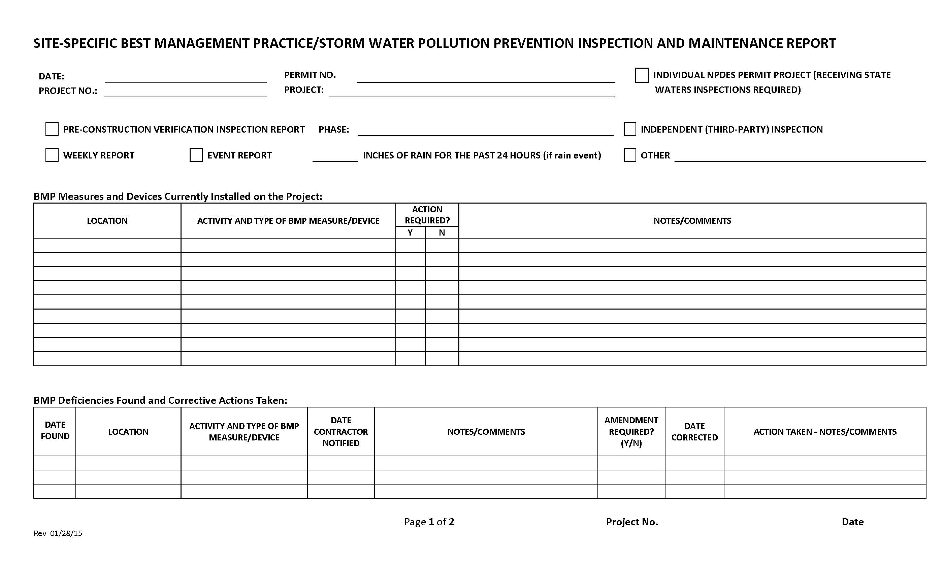
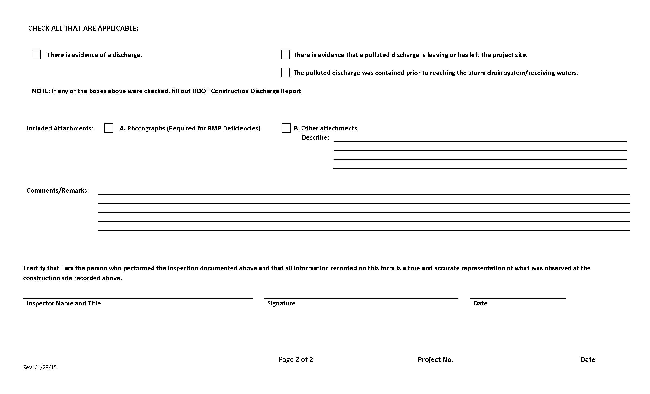

Oahu Attachment E2 – Corrective Action Reports (SWPPP Section 7.2.12) Rev. 02/25/14
Hawaii Department of Transportation Corrective Action Report

Section 10.1 “Corrective Actions” Defined
Corrective actions are actions taken in compliance with this section to:
a. Repair, modify, or replace any storm water control used at the site
b. Clean up and properly dispose of spills, releases, or other deposits
c. Remedy a permit violation

Section 10.2.1. Triggering Events
The following are triggers that require corrective action be taken (this triggering condition is to be documented within 24 hours of discovering the occurrence):
    - A required storm water control was never installed, was installed incorrectly, or not in accordance with the requirements in HAR Chapter 11-55, Sections 5 and/or 6.
- The Contractor/Engineer becomes aware that the storm water controls installed and being maintained are not effective enough for the discharge to meet applicable water quality standards or applicable requirements in HAR Chapter 11-55, Section 6.1. The Contractor shall notify the Engineer immediately. The Engineer will notify the Department of Health by the end of the next work day.
Date/time Engineer notified by Contractor
Date/time DOH notified by Engineer
- One of the prohibited discharges below is occurring or has occurred:
- Wastewater from washout of concrete
- Wastewater from washout and cleanout of stucco, paint, form release oils, curing compounds and other construction materials
- Fuels, oils, or other pollutants used in vehicle and equipment operation and maintenance
- Soaps, solvents, or detergents used in vehicle and equipment washing
- Toxic or hazardous substances from a spill or other release

Section 10.2. Requirements for Taking Corrective Actions
The Contractor shall complete corrective actions in accordance with the deadlines specified below. In all circumstances, the Contractor shall immediately take all reasonable steps to minimize or prevent the discharge of pollutants until a permanent solution is installed and made operational, including cleaning up any contaminated surfaces so that the material will not discharge in subsequent storm events. Immediately means the same day the condition is discovered, unless it is too late in the day, in which initiation of corrective action must begin on the following work day.
Following any of the above triggering events, the Contractor shall install a new or modified control and make it operational, or complete the repair, by no later than 7 calendar days from the time of discovery. If it is infeasible to complete the installation or repair within 7 calendar days, the Contractor shall document and submit to the Engineer, for his agreement, why it is infeasible to complete the installation or repair within the 7 calendar day timeframe and document a schedule for installing the storm water control(s) and making it operational as soon as practicable after the 7-day timeframe.
Date installation/repair completed or date/time prohibited discharge ceased
Reason it is infeasible to complete installation or repair within 7 calendar days and proposed schedule (if applicable)

10.4.1. Initial Report (24 Hours)
Within 24 hours of discovering the occurrence of one of the triggering conditions in HAR Chapter 11-55, Section 10.2.1. at the site, the Contractor must complete the following:
- The nature of the condition identified
- The date and time of the condition identified and how it was identified

10.4.2. Final Report (7 Days)
Within 7 calendar days of discovering the occurrence of one of the triggering conditions in HAR Chapter 11-55, Section 10.2.1. at the site, the Contractor must complete a report of the following:
- Any follow-up actions taken to review the design, installation, and maintenance of storm water controls, including the dates such actions occurred
- A summary of storm water control modifications taken or to be taken, including a schedule of activities necessary to implement changes, and the date the modifications are completed or expected to be completed
- Notice of whether SWPPP modifications are required as a result of the condition identified or corrective action

Section 10.2.2. SWPPP Modification Due to Corrective Actions
Where corrective actions result in changes to any of the storm water controls or procedures documented in the SWPPP, modify the SWPPP accordingly within 7 calendar days of completing corrective action work.
❑ Date SWPPP modified should be indicated in the Amendment Log

Section 10.3 Corrective Actions Required by the Department of Health (DOH)
The Contractor shall comply with any corrective actions required by the department as a result of permit violations found during an inspection by DOH or EPA.
Was the Corrective Action triggered by a DOH/EPA inspection?
❑ Yes  No
❑ Date of DOH/EPA Inspection

Section 10.4.3. Certification
The certifying person and duly authorized representative shall meet the requirements of Hawaii Administrative Rules 11-55, Appendix A, Section 15.
I certify under penalty of law that this document and all attachments were prepared under my direction or supervision in accordance with a system designed to assure that qualified personnel properly gather and evaluate the information submitted. Based on my inquiry of the person or persons who manage the system, or those persons directly responsible for gathering the information, the information submitted is, to the best of my knowledge and belief, true, accurate, and complete. I am aware that there are significant penalties for submitting false information, including the possibility of fine and imprisonment for knowing violations.

Section 10.4.4. Corrective Action Report

NOTE: Corrective Actions shall be documented in the Site-Specific Best Management Practice/Storm Water Pollution Prevention Inspection and Maintenance Report, See Attachment E1.

Oahu Attachment E3 – HDOT Highways Oahu Construction Discharge Response Flow Chart, Rev. 11/17/2015; HDOT Construction Discharge Report Form (SWPPP Section 7.2.12) Rev. 1/28/15
(See Next Pages)
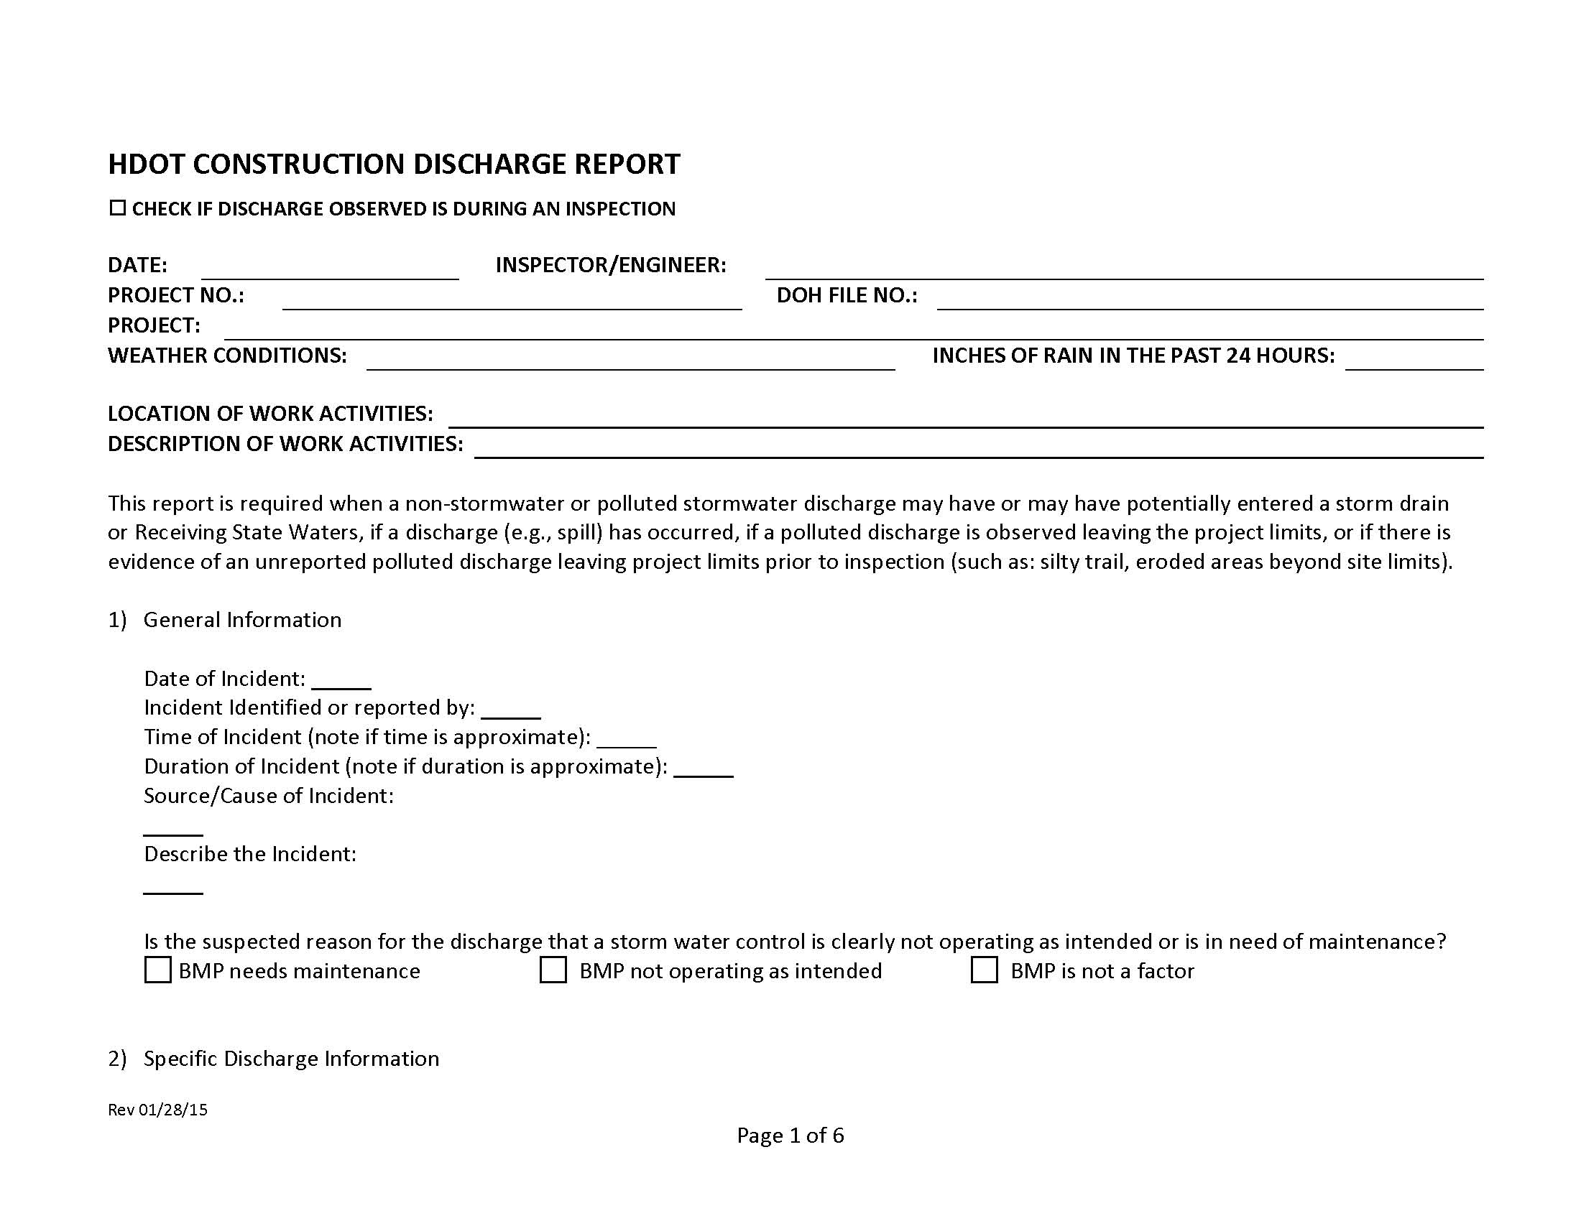
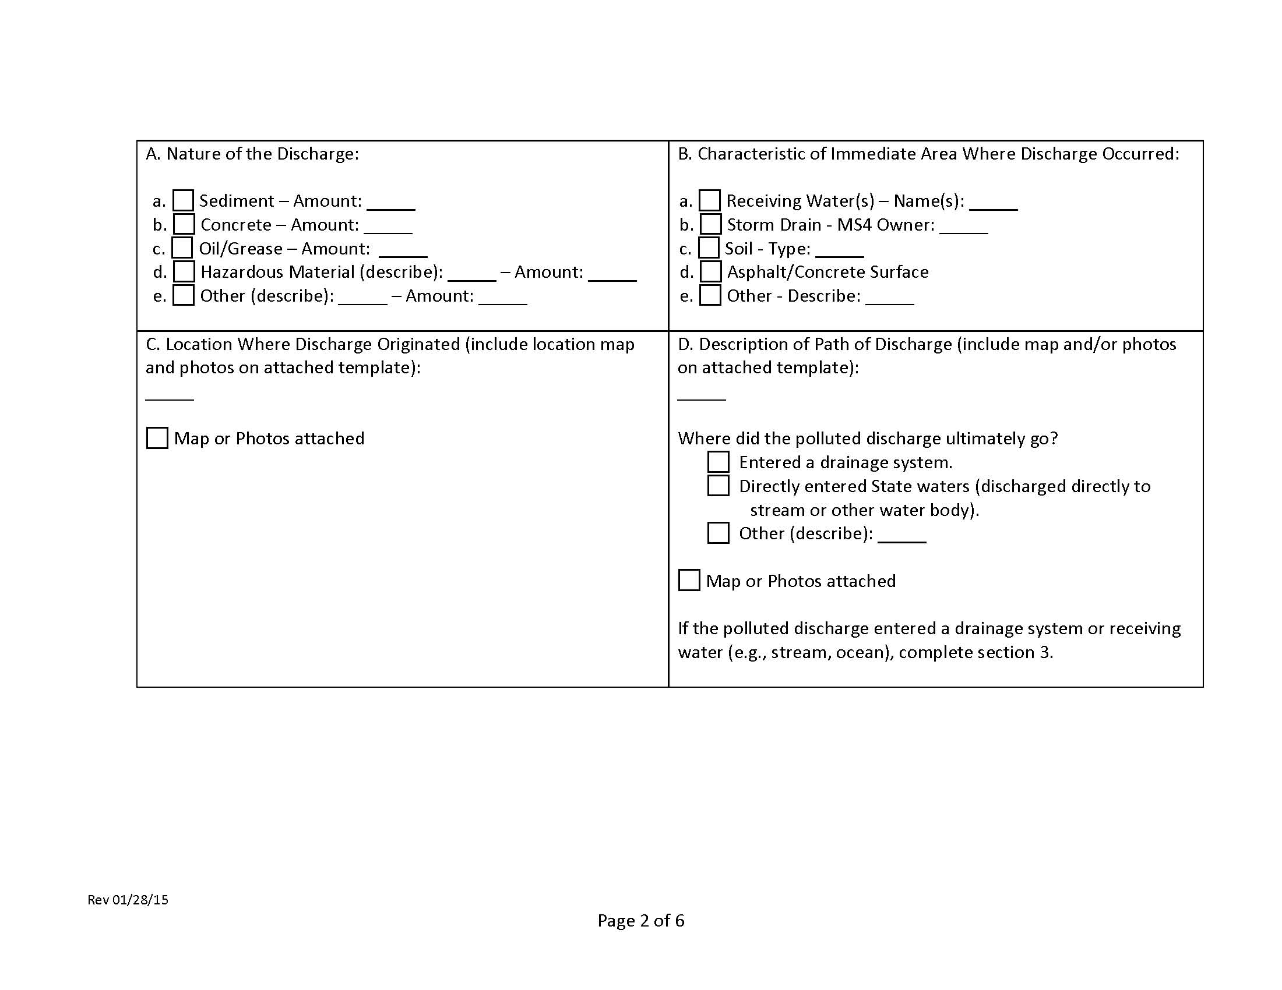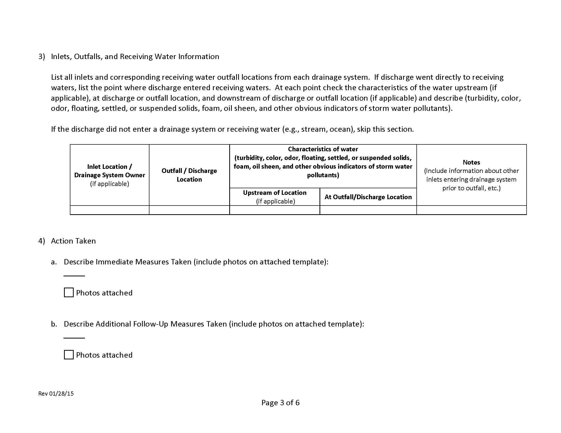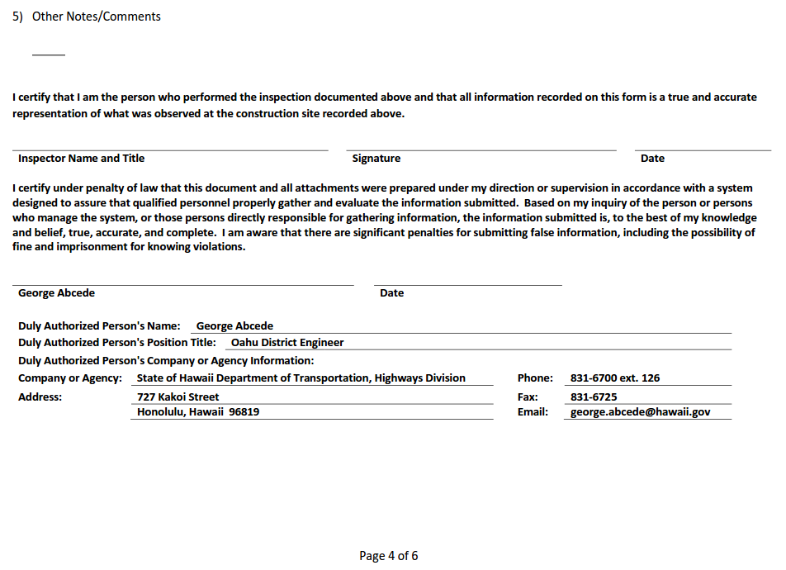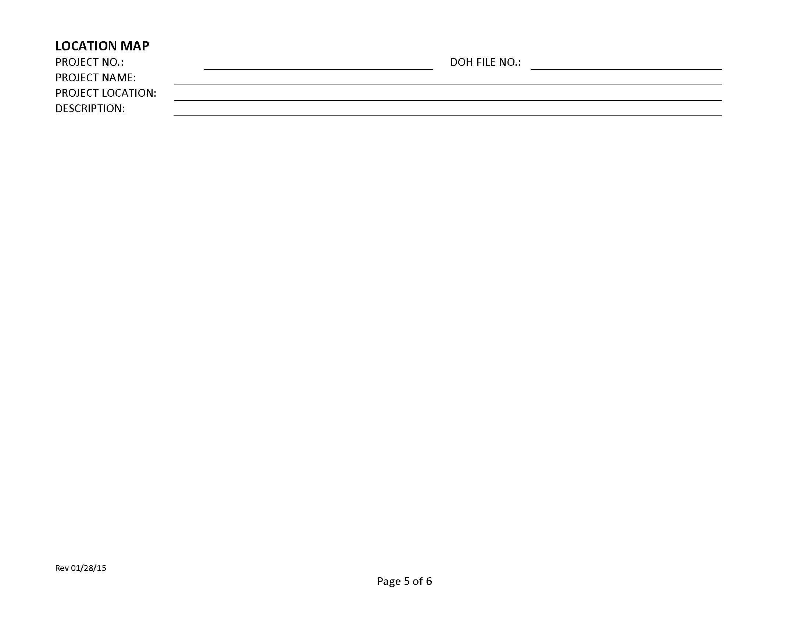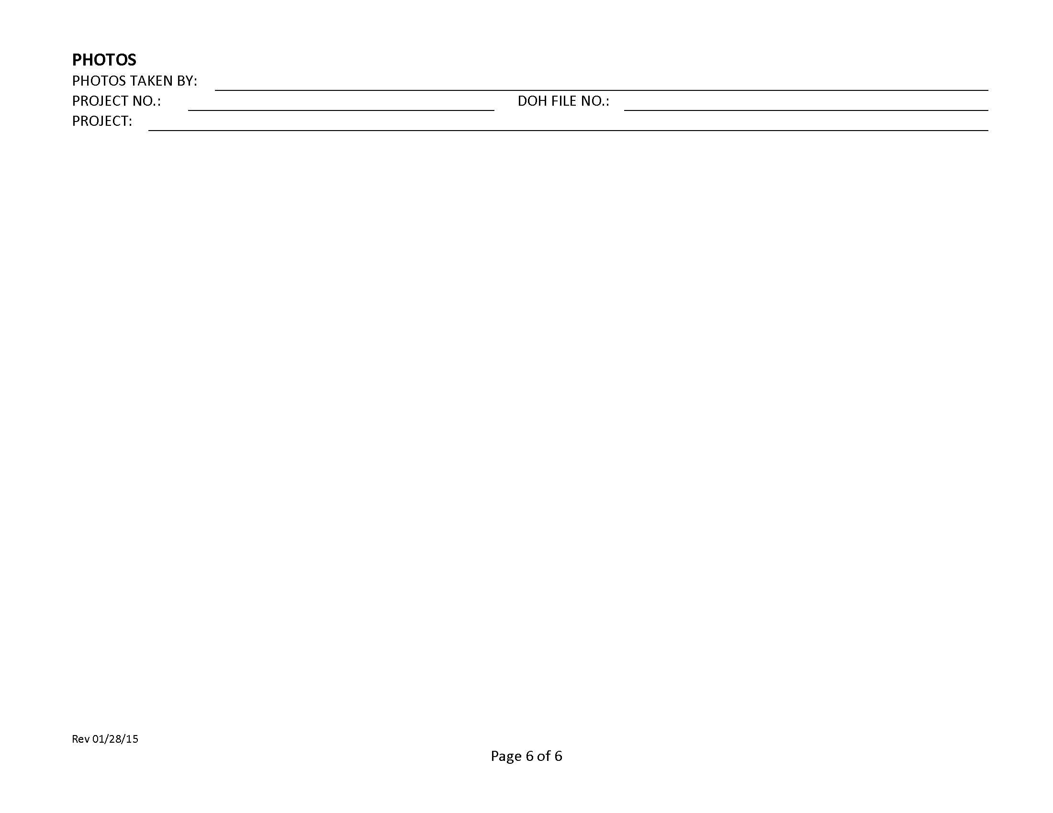

Oahu Attachment E4 – Monthly Compliance Report

Hawaii Department of Transportation Monthly Compliance Report

A Monthly Compliance Report is required to be completed within 2 working days of the end of the month. This report must be kept on-site and made available by the end of the next business day when requested by DOH. The following is required to be addressed in the Monthly Compliance Reports and include attachments as necessary.

❑ Any instances of non-compliance or corrective actions
❑ Changes to the information on file with DOH

If the activity is in compliance and none of the information on file with the department requires updating, or there were no incidences of non-compliance, preparation of the monthly compliance information is still required which states:
❑ No changes, updates, or any incidences of non-compliance to report.

The certifying person and duly authorized representative shall meet the requirements of Hawaii Administrative Rules 11-55, Appendix A, Section 15. The certifying person or duly authorized representative is required to sign the Monthly Compliance Reports with the following certification statement:

I certify under penalty of law that this document and all attachments were prepared under my direction or supervision in accordance with a system designed to assure that qualified personnel properly gather and evaluate the information submitted. Based on my inquiry of the person or persons who manage the system, or those persons directly responsible for gathering the information, the information submitted is, to the best of my knowledge and belief, true, accurate, and complete. I am aware that there are significant penalties for submitting false information, including the possibility of fine and imprisonment for knowing violations.
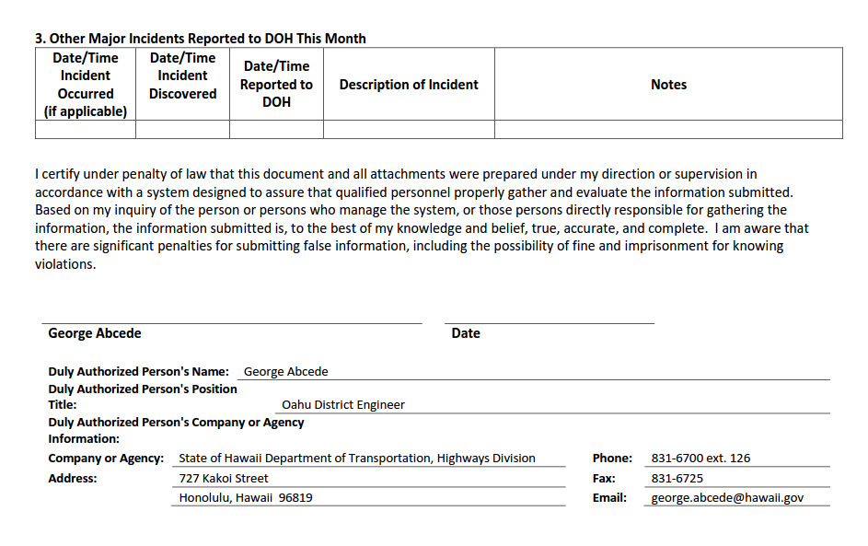

Oahu Attachment E5 – Receiving State Waters Inspection Report for Individual NPDES Permits (SWPPP Section 7.2.12) Rev. 01/28/15

No Individual Permit

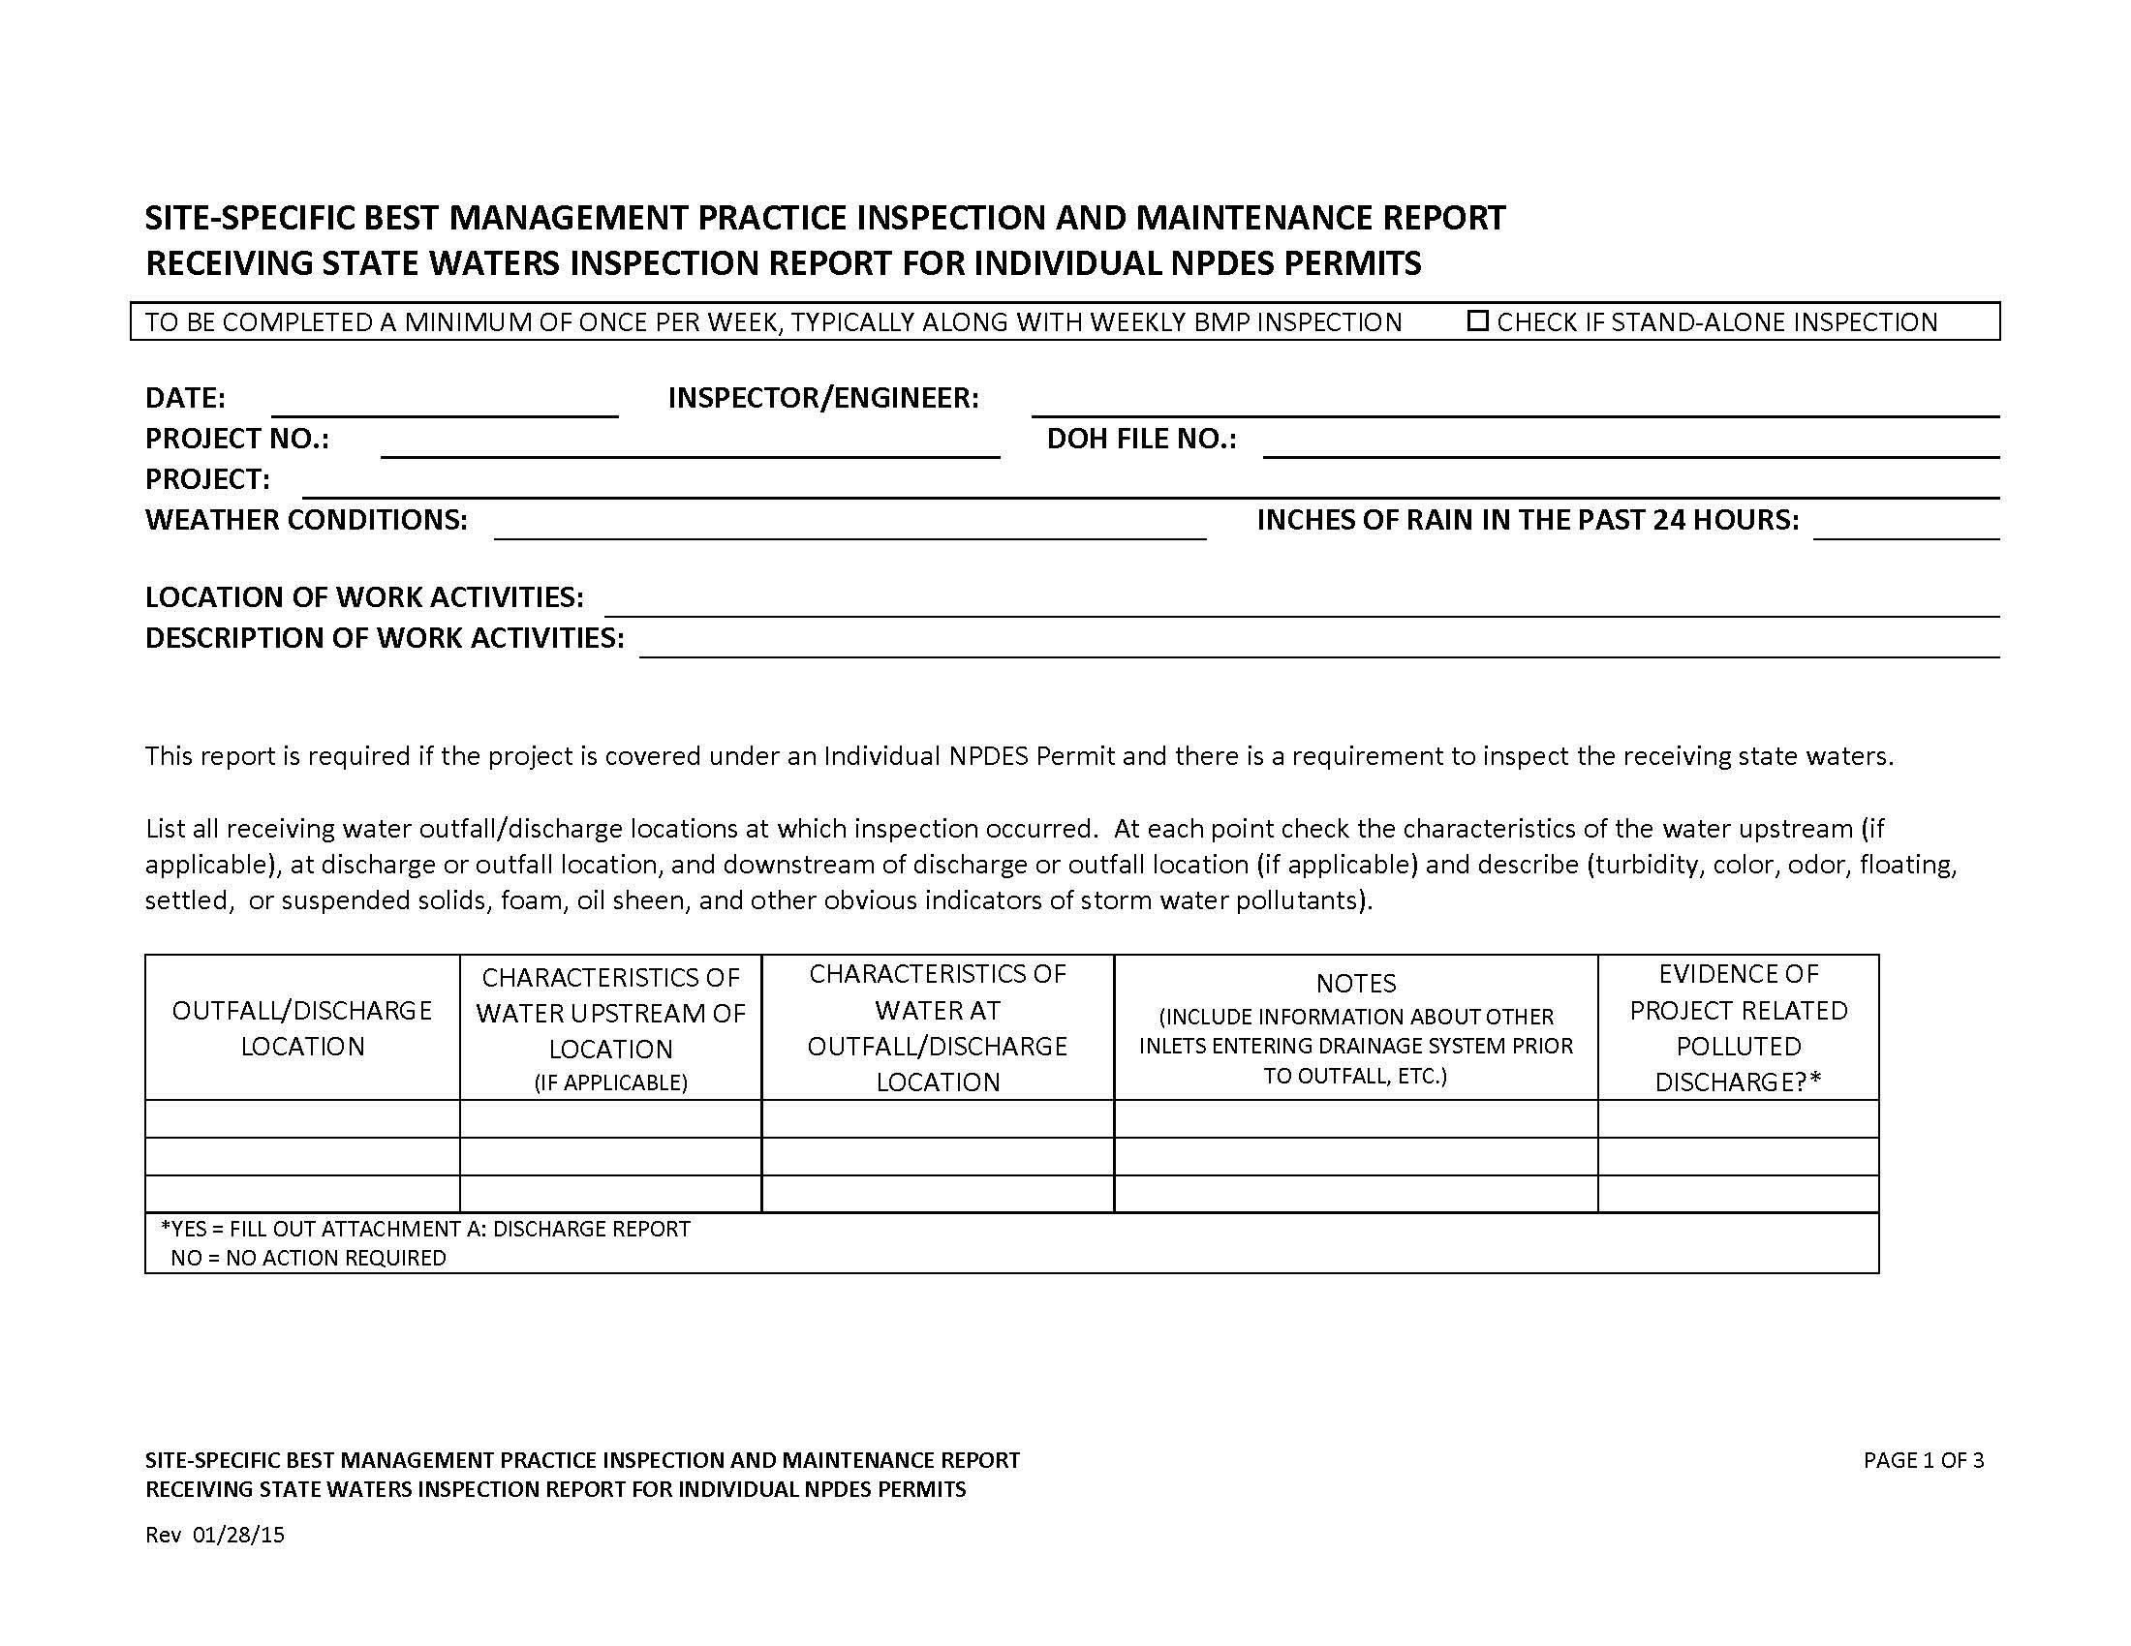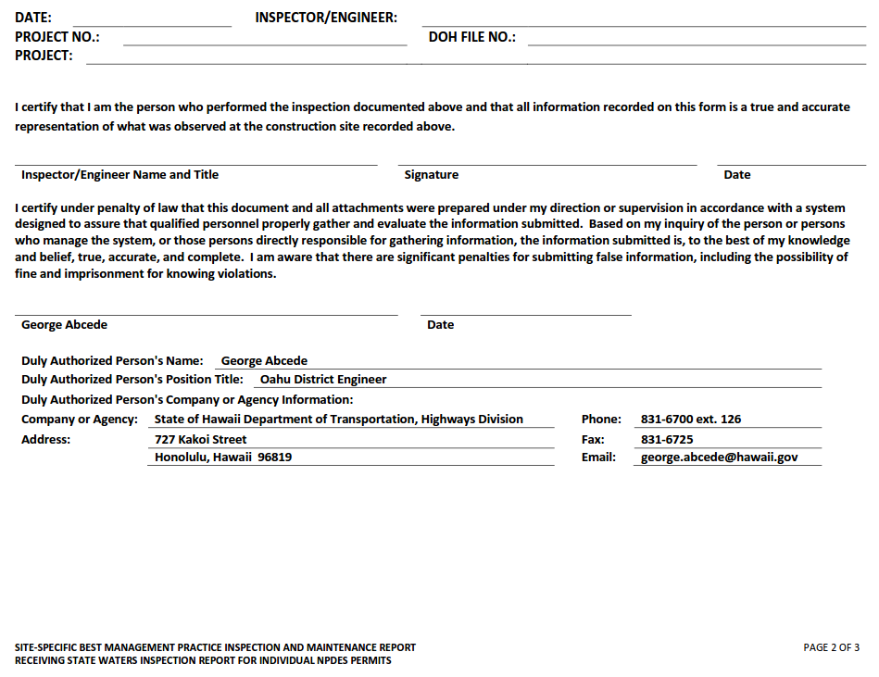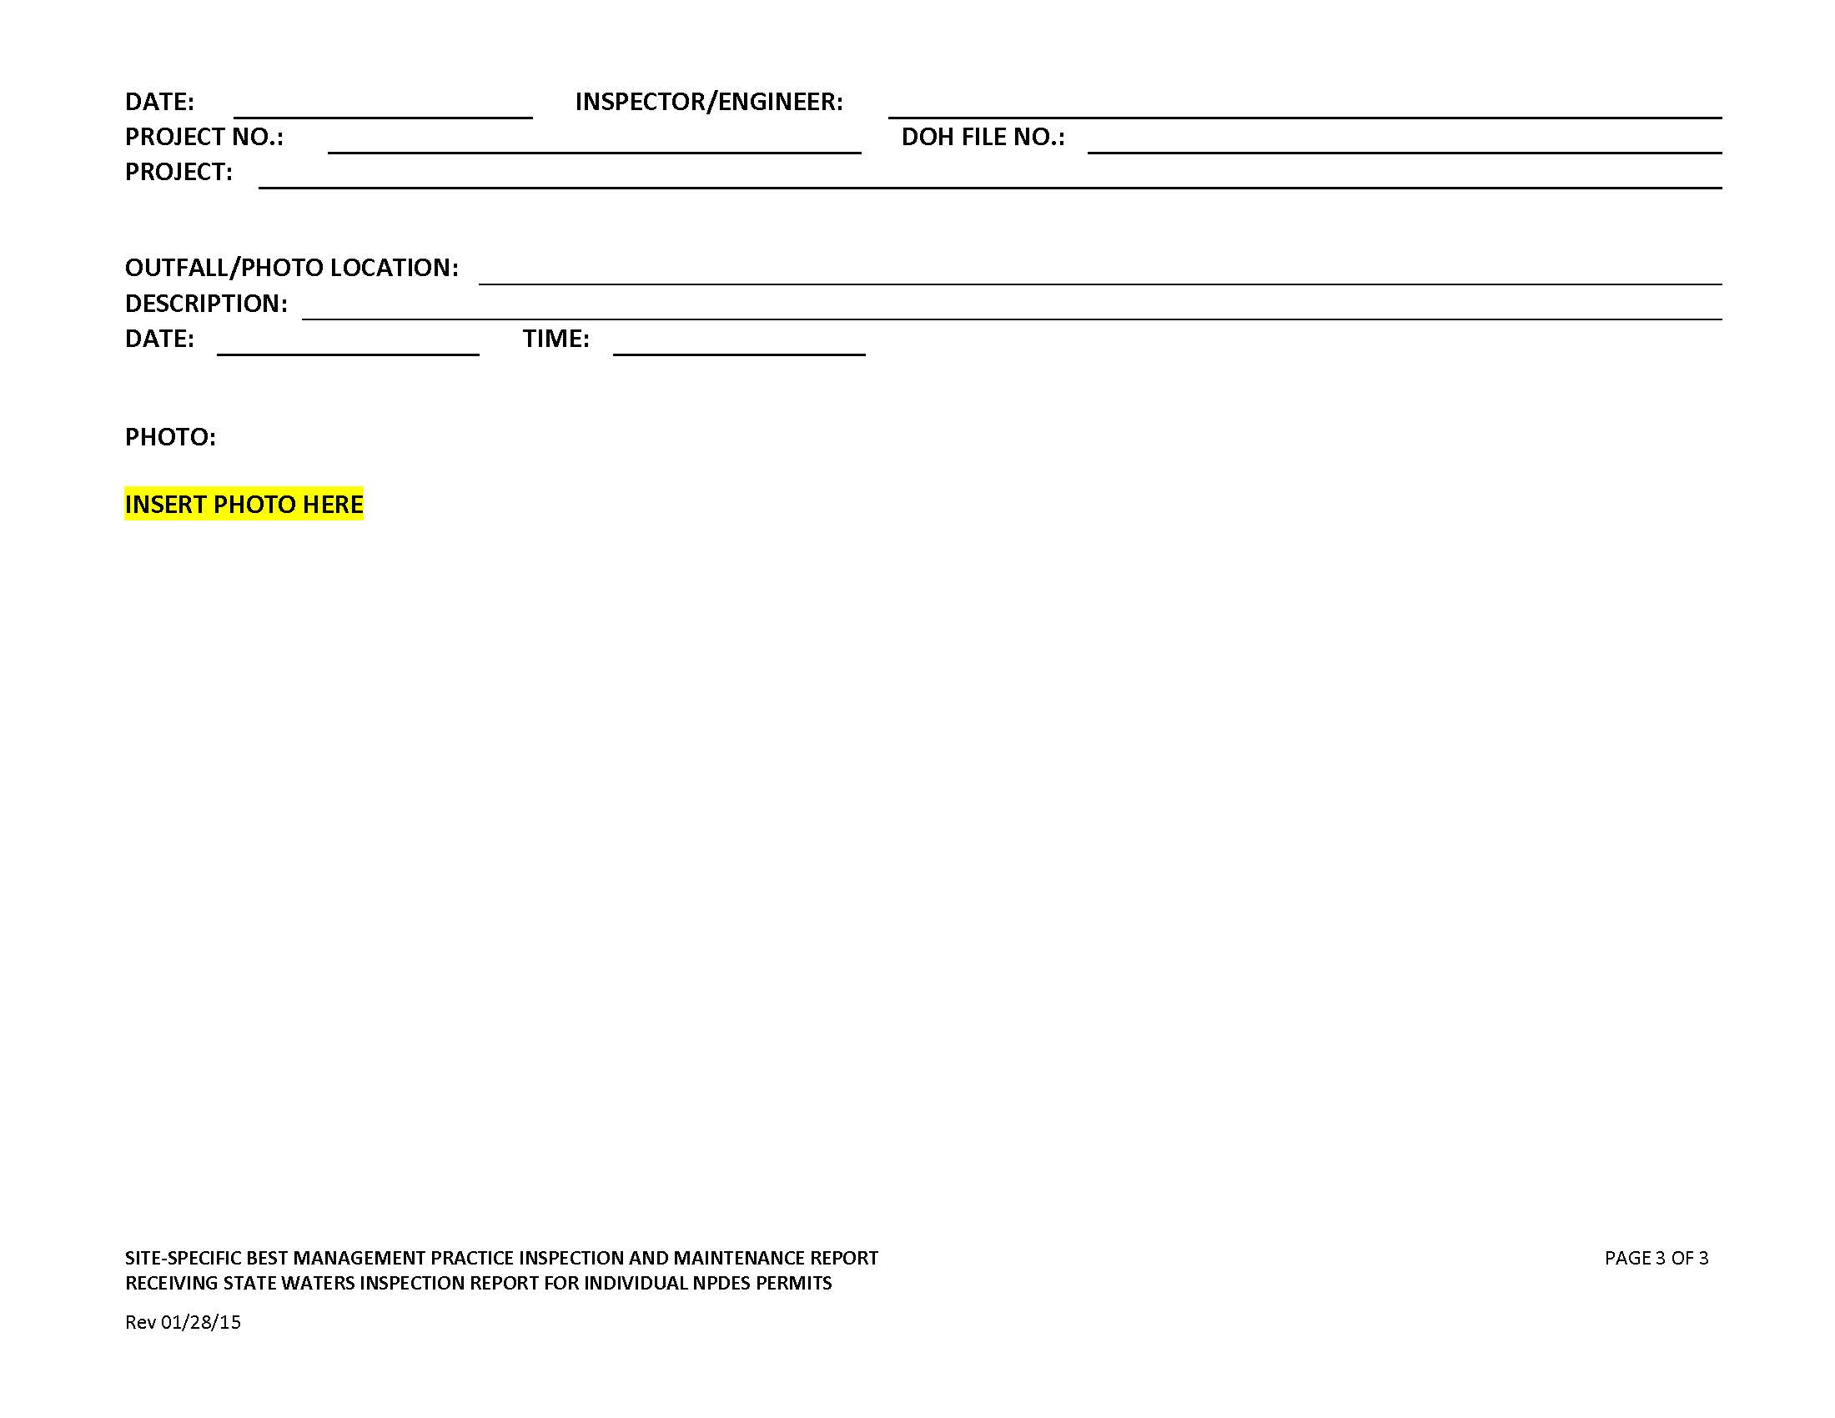

Kauai/Maui/Hawaii Attachment E1 – HDOT SWPPP Inspection Report for Kauai, Maui, and Big Island Land-Based BMPs

HDOT INSPECTION REPORT FORM
Date: Project/Site: Permit No.: HI
Inspector’s Name:
Inspector’s Title:
Weather:
Rain Gauge Site and Amount in Inches (If applicable) inches

The Following Areas Have been Inspected | Yes | No | N/A | Notes
9.1.5a All areas that have been cleared, graded, or excavated and that have not yet completed stabilization consistent with section 5.2
9.1.5b All storm water controls (including pollution prevention measures) installed at the site to comply with this permit
9.1.5c Material, waste, borrow, or equipment storage and maintenance areas that are covered by this permit
9.1.5d All areas where storm water typically flows within the site, including drainageways designed to divert, convey, and/or treat storm water
9.1.5e All points of discharge from the site
9.1.5f All locations where stabilization measures have been implemented

9.1.5 Were any portions of the site not inspected due to unsafe conditions? YES  NO 
If answering yes above, provide reasons why inspection of the site (or portions thereof) were unsafe and locations not inspected

Site Specific Best Management Practices (BMPs) Plan | Yes | No | N/A | Date Corrected | Notes
Is a copy of the Site Specific BMPs plan available at the site?
Is the Site Specific BMPs plan certified, signed, and dated?
Is the Site Specific BMPs plan current and up-to-date?
Are accompanying erosion and sediment control (ESC) drawings available at the site?
Are the Erosion and Sediment Control (ESC) drawings up-to-date?
Are all NPDES permits available at the site?
Are inspection records available at the site?

Insert or removes rows, fill in blanks to tailor to your site.

Best Management Practices | Location | Installed Per Specifications (Y/N) | Adequate | Needs Maintenance | N/A | Date Corrected | Notes
Controlling Storm Water Flowing onto and through the Project (run-on diversion, silt fence, vegetated filter strips and buffers, etc.
Soil Stabilization (topsoil management, seeding and planting, mulching, geotextiles and mats, etc.)
Slope Protection (seeding and planting; mulching; geotextiles and mats; slope roughening, terracing and rounding, etc.)
Storm Drain Inlet Protection
Perimeter Controls and Sediment Barriers (silt fence, vegetated filer strips and buffers, etc.)
Sediment Basins and Detention Ponds (sediment traps, sediment basins, etc.)
Stabilized Ingress/Egress Structures
Additional Erosion and Sediment Control BMPs
Material Handling and Waste Management (hazardous waste management, concrete waste management, etc.)
Material Storage
Spill Prevention/Control
Baseyards/Staging Areas
Washout Areas
Concrete Washout/Waste
Paint Washout/Waste
Proper Equipment/Vehicle Fueling and Maintenance Practices
Equipment/Vehicle Fueling
Equipment/Vehicle Cleaning
Equipment/Vehicle Maintenance
Additional Non-Erosion or Sediment Control BMPs
Post Construction BMPs (flared culvert end sections, rip-rap and gabion inflow protection, outlet protection and velocity dissipation devices, etc.)
Other
Sawcutting
Dust Control
Dewatering

Insert or removes rows, fill in blanks to tailor to your site.
Site Conditions | Yes | No | N/A | Notes and Corrective Actions
9.1.6.1 Do all erosion and sediment controls and pollution prevention controls installed, appear to be operational, and working as intended to minimize pollutants discharges?
9.1.6.1 Any controls need to be replaced, repaired, or maintained in accordance with HAR Ch. 11-55 sections 5.1.1.4 and 5.3.2?
9.1.6.2 Any conditions present that could lead to spills, leaks, or other accumulations of pollutants on the site?
9.1.6.3 Any locations where new or modified storm water controls are necessary to meet the requirements of HAR Ch. 11-55 sections 5 and/or 6?
9.1.6.5 Any incidents of noncompliance observed?
Are off-site flows entering the construction site?
9.1.6.4 At points of discharge are there signs of visible erosion and sedimentation that have occurred and are attributable to the discharge?
9.1.6.4 On the banks of any state waters flowing within the property boundaries are there signs of visible erosion and sedimentation that have occurred and are attributable to the discharge?
9.1.6.4 On the banks of any state waters flowing adjacent to the property are there signs of visible erosion and sedimentation that have occurred and are attributable to the discharge?
Are construction materials/debris/trash/soil stored or disposed of properly at the site?
Is there vehicle tracking from the site to receiving streets?
Do locations exist where additional or revised BMPs are needed?
Do locations exist where BMPs may no longer be necessary and may be removed?
Does your site evaluation indicate a need to update or revise the current Site Specific BMPs plan and/or accompanying erosion and sediment control drawings?

9.1.6.6 Discharges Observed During Inspection
Is a discharge occurring during the inspection? YES  NO 
If answering YES above answer the following:
9.1.6.6a Identify all points of the property from which there is a discharge
9.1 Is there a potential for downstream erosion? YES  NO 
If YES continue to the next question. If NO go to 9.1.6.6b and inspect at the Discharge Point.
9.1 Does the discharge enter an MS4 or separate drainage system prior to the receiving water? YES  NO 
If YES go to 9.1.6.6b and inspect Where it Enters the Drainage System. If NO continue to the next question.
9.1 Does the effluent comingle with offsite water or pollutant sources prior to discharging to the receiving water? YES  NO 
If YES go to 9.1.6.6b and inspect at a Location Representative of the Discharge Quality Prior to Comingling.
If NO go to 9.1.6.6b and inspect at the Receiving Water.

9.1.6.6b What color is the discharge?

9.1.6.6b Is there an odor? Describe if possible.

9.1.6.6b Are there floating, settled, or suspended solids? If so, describe?

9.1.6.6b Is there foam?

9.1.6.6b Does the discharge contain an oil sheen?

9.1.6.6b Are there any other obvious indicators of storm water pollutants in the discharge?

9.1.6.6c Is the suspected reason for the discharge that a storm water control is clearly not operating as intended or is in need of maintenance?

Photos
Photos taken during the BMP inspection documented above are:
❑ Attached
❑ Inserted
❑ Not taken, attached, or inserted.
(Insert photos in this section if you so choose.)

I certify that I am the person who performed the inspection documented above and that all information recorded on this form is a true and accurate representation of what was observed at the construction site recorded above. Any photographs attached that were taken during the inspection are a true, accurate, and unaltered representation of what was observed during the inspection documented above.

Inspector’s Printed Name: Title:

Inspector’s Signature: Date of Inspection:

Inspector’s Printed Name: Title:

Inspector’s Signature: Date of Inspection:

The certifying person and duly authorized representative shall meet the requirements of Hawaii Administrative Rules 11-55, Appendix A, Section 15.

I certify under penalty of law that this document and all attachments were prepared under my direction or supervision in accordance with a system designed to assure that qualified personnel properly gather and evaluate the information submitted. Based on my inquiry of the person or persons who manage the system, or those persons directly responsible for gathering the information, the information submitted is, to the best of my knowledge and belief, true, accurate, and complete. I am aware that there are significant penalties for submitting false information, including the possibility of fine and imprisonment for knowing violations.

Signature: Date:
Duly Authorized Person’s Name: Harry H. Takiue
Duly Authorized Person’s Position Title: Hawaii District Engineer
Duly Authorized Person’s Company or Agency: Department of Transportation
Department: Department of Transportation
Division: Department of Transportation, Highways
Phone Number: (808) 933-8866 Fax No.:
Person Email: Harry.H.Takiue@hawaii.gov

Statewide Attachment E6 – HDOT Inspection Report for In-Water Work (IWPPP Section 7.2.12A)
Use this inspection report for daily in-water visual inspections. The questions below apply to the area outside the isolated and confined work area.

HDOT IN-WATER INSPECTION REPORT FORM
Date: Project/Site: Permit No.: HI
Inspector’s Name:
Inspector’s Title:
Weather:
Rain Gauge Site and Amount in Inches (If applicable) inches

Is water flowing at the site? YES  NO 

Is there a Turbidity Plume? YES  NO 
If yes, stop work immediately and investigate the source of the plume. Follow the procedures in Section 7.2.12A Procedures for Inspection, Maintenance, and Corrective Actions for In-Water Work Areas.

Are there any other indicators of a discharge? YES  NO 
Is so, describe?

Is the suspected reason for the discharge that a storm water control is clearly not operating as intended or is in need of maintenance?
YES  NO 
If so, describe?

Photos
Photos taken during the BMP inspection documented above are:
❑ Attached
❑ Inserted

I certify that I am the person who performed the inspection documented above and that all information recorded on this form is a true and accurate representation of what was observed at the construction site recorded above. Any photographs attached that were taken during the inspection are a true, accurate, and unaltered representation of what was observed during the inspection documented above.

Inspector’s Printed Name: Title:

Inspector’s Signature: Date of Inspection:

Inspector’s Printed Name: Title:

Inspector’s Signature: Date of Inspection:

The certifying person and duly authorized representative shall meet the requirements of Hawaii Administrative Rules 11-55, Appendix A, Section 15.

I certify under penalty of law that this document and all attachments were prepared under my direction or supervision in accordance with a system designed to assure that qualified personnel properly gather and evaluate the information submitted. Based on my inquiry of the person or persons who manage the system, or those persons directly responsible for gathering the information, the information submitted is, to the best of my knowledge and belief, true, accurate, and complete. I am aware that there are significant penalties for submitting false information, including the possibility of fine and imprisonment for knowing violations.

Signature: Date:
Duly Authorized Person’s Name: Harry H. Takiue
Duly Authorized Person’s Position Title: Hawaii District Engineer
Duly Authorized Person’s Company or Agency: Department of Transportation
Department: Department of Transportation
Division: Department of Transportation, Highways
Phone Number: (808) 933-8866 Fax No.:
Person Email: Harry.H.Takiue@hawaii.gov

Attachment F – Spill Prevention and Response Procedures (SWPPP/IWPPP Section 7.2.11.1)
Spill Prevention and Control Plan (SM-10)

Description Practices and procedures to reduce or prevent leaks or spills of fuels, oil, and other chemicals which may be discharged into the storm drain system or adjacent water bodies.

Applications Construction projects involving the storage of chemicals or hazardous
substances.

Installation and General Requirements include the following:
Implementation • Store hazardous materials and wastes in covered containers and
Requirements protect containers from vandalism;
• Maintain an ample supply of cleanup materials for spills shall be
readily accessible;
• Train employees on proper spill prevention and cleanup; and
• Review spill response requirements at all applicable work sites.
Cleanup Requirements include the following:
• Immediately clean up leaks and spills;
• Use minimal water to clean up spills on paved surfaces. For small
spills, use a rag. For general cleanup, use a damp mop. For larger
spills, use absorbent materials. Properly dispose of materials used
to clean up hazardous materials;
• Do not hose down or bury spills; and
• Eliminate the source of the spill to prevent a discharge or continuation of an ongoing discharge.

Reporting includes the following:
• Report significant spills to the U.S. coast Guard, DOH Clean Water Branch, Hawaii State Office of Hazard Evaluation and Emergency Response, and City and County of Honolulu agencies, such as the Fire Department and
• Per federal regulations, report significant spills of oil onto an
adjoining shoreline or into a water body to the National Response
Center at 800-424-8802 (24 hour).

Vehicle and equipment maintenance activities requirements include the
following:
• Use a designated area and/or secondary containment for on-site
repair or maintenance activities. These areas shall be located away
from drainage courses;
• Complete regular inspections of on-site vehicles and equipment,
including delivery trucks and employees’ vehicles, for leaks. Do not
allow vehicles or equipment with leaks on-site. Provide Vehicle and Equipment Maintenance BMPs in SM-12 if repair must be made on site.
• Secondary containment devices such as drop cloths and drain pans
shall be used to catch leaks or spills while removing or changing
fluids from vehicles or equipment;
• Place drip pans or absorbent materials under paving equipment not
in use;
• Use absorbent materials on small spills. Do not hose down or
bury spills. Remove and properly dispose of cleanup materials;
• Immediately transfer used fluids to the appropriate waste or
recycling containers. Avoid leaving full drip pans and open
containers on-site;
• Drain excess oil from oil filters prior to disposal by placing filter in a
funnel over a waste oil recycling drum. Recycle oil filters if this
service is available or dispose in accordance with Federal, State, and Local requirements;
Installation and • Store all cracked batteries in a non-leaking secondary container with cover
Implementation even if the acid appears to have drained out. Handle dropped
Requirements batteries as cracked batteries until assured it is not leaking.
(Continued) • Dispose of or recycle oil in accordance with Federal, State, and Local requirements. Store in water-tight container and provide cover to prevent containers from coming into contact with rainwater or secondary containment.

Vehicle and equipment fueling activities requirements include the
following:
• Use designated areas for required on-site fueling. Fueling areas
shall be located away from drainage courses;
• Avoid “topping off” of fuel tanks; and
• Use secondary containment devices such as drain pans to catch
spills or leaks while fueling.

Limitations Use of a private spill cleanup company may be necessary.

Inspections and • Update spill prevention and control plans and stock necessary
Maintenance cleanup materials as the chemicals used or stored on-site change.
• Ample supplies of materials for spill control and cleanup shall be
located on-site near maintenance and material storage or unloading
areas.

Emergency Spill Response Plan

Procedures for expeditiously stopping, containing, and cleaning up spills, leaks, and other releases (7.2.11.1a).

Spill Coordinator
The Contractor shall appoint a Primary and Secondary Emergency Spill Response Coordinator who will be responsible for the reporting of spills, coordinating contractor personnel for spill cleanup, subsequent site investigations, and associated reports. In the event of a spill, the Emergency Spill Response Coordinator will be responsible for determining the extent of the containment/isolation area and cleanup methods. Include Names, positions, and emergency contact information.
The Contractor shall make contact with a Spill Cleanup Emergency Response Contractor prior to start of construction to provide sufficient information for the spill contractor to be prepared should they receive a call in the event of an emergency.

Immediate Response
All spills regardless of size must be reported to the Emergency Spill Response Coordinator and the (HDOT Construction Resident Engineer/Project Engineer/Construction Inspector). The person observing the incident will take the following actions:
• Assess the safety of the situation (including the risk to the surrounding public).
• Alert nearby personnel and secure the immediate area for safety.

If the person is aware the chemical spilled is not toxic or a known petroleum product do the following:
• Make every effort to remove potential ignition sources and stop the source of the spill.
• Clean the spill using absorbent materials available on-site. Do not hose down or bury spills. Remove and properly dispose of cleanup materials.
• Promptly notify the Emergency Spill Response Coordinator. Report name, the spill location, material spilled, and the extent of the incident.

Upon learning of the spill, the Emergency Spill Response Coordinator will implement the following measures:
• Assess the safety of the situation (including the risk to the surrounding public).
• If the source of the spill is toxic or unknown, immediately notify the Fire Department and ask for assistance from the HAZMAT team.
• Secure the area by stopping traffic if necessary and install barricades or safety fencing around the area.
•If safe to do so, prevent hazardous material from entering the stormwater or sewer system or any waterbodies by covering/blocking any drains in the spill area, and providing containment BMPs to either prevent stormwater from contacting hazardous material or contain commingled stormwater.
•If safe to do so, absorbent materials will be applied to the spill area. Contaminated soils and vegetation will be excavated and temporarily placed on and covered by plastic sheeting or in an appropriate container or surrounded by impermeable lined berms in a containment area a minimum of 100 feet away from any wetland or waterbody, until proper disposal is arranged.
• Notify appropriate agencies as required by Federal, State, and local regulations.
•For petroleum spills, provide notification if the release meets any of conditions the below:
  - Greater than 25 gallons
  - Not cleaned within 72 hours
  - Enters a storm drainage system or state waters
• Arrange for proper disposal (including contaminated personal protective equipment and/or cleanup supplies) in accordance with Federal, State, and local regulations and Manufacturer’s instructions if known.
• If a spill is beyond the scope of on-site equipment and personnel, contact the Spill Cleanup Emergency Response Contractor to further contain and clean up the spill.
• Notify the (HDOT Construction Resident Engineer/Project Engineer/Construction Inspector).

Contents of the Spill kits shall be determined by the Contractor based on the anticipated type and quantity of hazardous material to be stored/used on-site. The kit should contain at minimum:
•55 gallon drum with lid
•absorbent pads (50)
•absorbent socks (12)
•absorbent pillows (5)
•1 pair goggles or faceshield
•1 pair elbow length gloves
•1 disposable apron
•disposable bags with ties (3)
•Include additional materials such as Absorbent Skimmers or Booms for work adjacent or over State Waters as needed.
•Include additional materials as necessary to secure the spill area.

Procedures for notification of appropriate facility personnel, emergency response agencies, and regulatory agencies where a leak, spill, or other release containing a hazardous substance or oil in an amount equal to or in excess of a reportable quantity consistent with HAR 11-55 subsection 5.3.4. and established under either 40 CFR Part 110, 40 CFR Part 117, or 40 CFR Part 302, occurs during a 24-hour period (7.2.11.1.b).
• Contact information must be in locations that are readily accessible and available.
• The Contractor shall take all reasonable measures to protect human health and the environment.
• For emergencies or life-threatening situations, call 911 first.

• Notify responsible parties listed below as required and immediately notify DOH Clean Water Branch and the National Response Center of the incident. The notification shall also include the identity of the pollutant sources and the implemented control or mitigation measures. Notify other agencies as required by Federal/State/Local laws. List additional agencies or personnel below as required.

1. Owner Contact/Emergency Contact Number: (HDOT Construction Resident Engineer/Project Engineer/Construction Inspector)

- Authorized Representative/ Emergency Contact Number: (HDOT District Engineer or -designated representative who can contact Authorized Representative)

Harry H. Takiue, Hawaii District Engineer…………………………………….808-933-8866

3. Contractor/ Emergency Contact Number: (Contractor Emergency Contact)

4. Department of Health
Clean Water Branch (During regular working hours): ……………………….808-586-4309
Hawaii State Hospital Operator (After hours):……………………………….. 808-247-2191
AND E-mail Clean Water Branch via email at cleanwaterbranch@doh.hawaii.gov

5. Hawaii Hazard Evaluation and Emergency Response (HEER) ………….808-586-4249
(After Hours) ……………………...808-247-2191
AND

Appropriate Local Emergency Planning Committee (LEPC)

For projects on Hawaii Island
Henry Silva, Hawaii County LEPC……………….………….808-936-0858

For projects on Oahu
Leland Nakai Department of Emergency Management……808-723-8958
LEPC……………………………………………….….808-723-8960
(After Hours)………………………………………….911

For projects on Kauai
Clifford Ikeda, Kauai Civil Defense……..…………..……….808-241-1800
(After Hours)………………………………………….808-241-6711

For projects in Maui County
Scott Kekuewa, Maui Fire Department…………………..….808-270-7911
(After Hours)………………………………………….911

6. National Response Center (NRC)…………………………………………..(800)424-8802
7. Coast Guard Operations Center, Honolulu (working hours) ……………. 808-522-8246
(After hours)…………………808-247-2191

8. County Fire Department/Police……………………………………………… 911
9. HDOT Tunnels Emergency Contact Number (After Hours)……………….808-485-6200
10. Contractor’s Spill Cleanup Emergency Response Contractor…………….xxx-xxx-xxxx

• If required, fill in and follow the requirements of the HDOT Corrective Action Report.

Attachment G – Waste Management Procedures (SWPPP/IWPPP Section 7.2.11.2)
Waste Management Procedures

The Contractor shall submit the DOH “Solid Waste Disclosure Form for Construction Sites” to the Engineer within 30 calendar days of contract execution. The form can be downloaded at: http://health.hawaii.gov/shwb/files/2013/06/swdiscformnov2008.pdf Attach signed copy, including solid waste generated by sub-contractors, in Attachment G.

Provide a copy of all the disposal receipts from the facility permitted by the Department of Health to receive solid waste to the Engineer monthly, this should also include documentation from any intermediary facility where solid waste is handled or processed, or as directed by the Engineer.

Solid Waste Management (SM-6)

Description Practices and procedures to prevent or reduce the discharge of
pollutants from construction site wastes to the drainage system or
adjacent water bodies.
Applications Construction projects generating non-hazardous solid wastes from
construction and demolition (C&D) activities. These wastes include
C&D wastes, inert fill material, and recycle/reuse material.
C&D wastes include materials originating from the demolition of roads,
buildings, or other structures. Materials generated from these
activities include concrete, brick, bituminous concrete, wood, masonry,
composition roofing, roofing paper, steel, plaster, and minor amounts
of metals.
Inert fill materials are wastes that are not contaminated with hazardous
materials such as asbestos or lead-based paint. Inert fill materials do
not decompose or produce leachate or other products harmful to the
environment. Inert fill materials include earth, soil, rock, cured asphalt,
brick, and clean concrete (no exposed steel-reinforcing rod) with no
dimension greater than eight inches.
Recycle/reuse materials include but are not limited to: asphalt
pavement, cardboard, concrete aggregate (no LBP, asbestos-free),
electronic equipment, excavated rock, soil (uncontaminated), Freon
from appliances, glass, green waste, metals, ferrous/non-ferrous, used
tires, wood and lumbers, furniture, etc.

Installation and • Separate contaminated clean up materials from C&D wastes.
Implementation Contamination may be from hazardous substances, friable
Requirements asbestos, waste paint, solvents, sealers, or adhesives. (See Section SM-9 Hazardous Waste Management)
• Inert fill material shall not contain vegetation, organic material, or
other solid waste.
• Inert fill materials shall not be mixed with other C&D waste.
• Provide waste containers of sufficient size and number to contain construction and domestic waste. Dumpsters should be securely lidded. Roll off containers
should have a cover to keep rain out or loss of waste during windy conditions. Waste containers shall meet all local and State solid waste management regulations
• Clean up and dispose of waste in designated waste containers.
• The Contractor's supervisory personnel shall be instructed regarding the correct practices for waste disposal. Post notices stating these practices in the office trailer and the Contractor shall be responsible for seeing that these practices are followed.

Limitations None

Inspections and • Inspect construction waste and recycling areas regularly.
Maintenance • Schedule solid waste collection regularly. Empty waste containers weekly or when they are two-thirds full, whichever is sooner.
• Schedule recycling activities based on construction/demolition
phases.
• Do not allow containers to overflow and clean up immediately if they do.

Sanitary/Septic Waste Management (SM-7)

Description Practices and procedures to reduce or prevent the discharge of sanitary wastes from construction sites into the storm drain system or
adjacent water bodies.
Applications Construction sites with temporary or portable sanitary/septic
waste systems.
Installation and • Locate sanitary facilities in a convenient place away from drainage
Implementation facilities and State Waters.
Requirements • Untreated wastewater shall not be discharged into the drainage system, State waters, to the ground or buried.
• Position sanitary facilities where they are secure and will not be knocked down.
• Comply with the State of Hawaii, Department of Health
requirements when using an on-site disposal system such as a
septic system.
• Avoid illicit discharges by properly connecting temporary sanitary
facilities to the sanitary sewer system.
• Sanitary/septic systems discharging to the sanitary sewer shall
comply with the local wastewater treatment plant requirements.
• A licensed service provider shall maintain sanitary/septic facilities
in good working order.
• Schedule regular waste collection by a licensed transporter at least once a week or as required.

Limitations None
Inspections and • Inspect and maintain facilities regularly.
Maintenance • Schedule regular waste collection.
• Prevent illicit discharges.

Hazardous Waste Management (SM-9)

Description Practices and procedures to prevent the discharge of hazardous waste to the land, storm drain system, sewer system, or adjacent water bodies.

Applications Handling procedures on construction sites involving one of the following
hazardous wastes:
• Paints and solvents;
• Petroleum products such as oils, fuels, and grease;
• Herbicides;
• Acids for cleaning masonry;
• Concrete curing and repair compounds; and
• Contaminated waste material.

Hazardous waste management shall also be implemented for wastes
from existing structures including:
• Sandblasted material such as grit or chips containing lead,
cadmium, or chromium-based paints;
• Asbestos; and
• Polychlorinated Biphenyls (PCBs). Older transformers are a
common source of PCBs.
Installation and Recognize potentially hazardous waste by implementing the following:
Implementation • Review product label and shipping papers;
Requirements • Identify key words such as flammable or ignitable (able to catch
fire); carcinogenic (causes cancer); toxic or poisonous (injures or
harms people or animals); and hazardous, danger, caustic or
corrosive (burns through chemical action). Hawaii
Administrative Rules (HAR) Title 11, Chapter 261 includes a list
of hazardous waste and criteria;
• Review safety data sheets (SDS), formerly material safety data sheets (MSDS) from the manufacturer and supplier of the product; and
• Contact DOH, Hazardous Waste Program Office at 586-4226 for
additional questions and information.

Material use practices and procedures for hazardous waste
management include the following:
• Dispose container only after all of the product has been used;
• Keep the original product label on the container since it includes
important safety and disposal information;
• Restrict amount of herbicide prepared to quantity necessary for
the current application. Comply with the recommended usage
instructions. Do not apply herbicides during or just before a rain
event; and
• Remove as much paint from brushes on painted surface. Do not
clean or rinse water-based paint brushes in soil, streets,
gutters, storm drains, or streams. Rinse from water-based
paints shall be discharged into the sanitary sewer system. Filter
and re-use solvents and thinners. Dispose of oil-based paints
and residue as a hazardous waste.
• See SM-2 Material Delivery and Storage and SM-3 Material Use for other requirements.

Waste recycling and disposal practices and procedures for hazardous
waste management include the following:
• Designate areas for collection of hazardous wastes;
• Store hazardous materials and wastes in covered containers and label according to applicable Resource Conservation and Recovery Act (RCRA) requirements and all other applicable federal, state, and local requirements;
• Provide appropriately-sized secondary containment for hazardous waste containers or cover to prevent from contact with rainwater and stormwater runoff;
• Keep wastes separate to prevent chemical reactions which
make recycling and disposal difficult;
• Recycle useful materials such as oil or water-based paint;
• Do not dispose of toxic liquid wastes (solvents, used oils, and
paints) or chemicals (additives, acids, and curing compounds) in
dumpsters allocated for construction debris;
• Schedule periodic waste collection to prevent overflow of
containers; and
• Ensure collection, removal, and disposal of hazardous waste
complies with manufacturer’s recommendations and in compliance with federal, state, and local requirements.
• Clean up spills immediately, using dry clean-up methods where possible, and dispose of used materials properly.
• Do not clean surfaces or spills by hosing the area down.
• Eliminate the source of the spill to prevent a discharge or a continuation of an ongoing discharge.

Hazardous waste management training shall include the following:
• Awareness of potential dangers from hazardous wastes;
• Identifying hazardous wastes;
• Proper hazardous waste storage and disposal procedures;
• Safety procedures for hazardous wastes;
• Placement of warning signs in areas recently treated with
chemicals;
• Use of cleanup materials for spills.

Limitations Hazardous waste that cannot be reused or recycled shall be disposed
of by a licensed hazardous waste hauler.

Inspections and • Regularly inspect hazardous waste collection and storage areas and
Maintenance containers.
• Schedule hazardous waste collection regularly.

[Edit as applicable] Litter Management Plan
Hawaii Belt Road, Hakalau Stream Bridge Rehabilitation, Bent #8 Scour Repair
- Construction site preparations.
Before the start of construction activities, during the mobilization process, proper litter waste receptacles will be located at the construction site. Litter receptacles will be placed within the boundaries of the project right-of-way or within a project related vehicle on-site. Construction debris receptacles that accept mixed reuse may also act as litter control receptacles.
- Daily Construction Site Litter Prevention Activities.

- Pre-Construction activities litter prevention and control activities.

- At the start of each work day, the active work areas of the construction site(s) will be inspected for litter debris.
- Litter debris found will be collected and properly sorted into the proper debris receptacle.
- Litter will be collected whether or not it was sourced from the job site and construction related activities.
- After collection, litter will be disposed of in appropriate waste containers and all practices outlined in the Waste Management Plan will be followed.
- Waste containers will be inspected regularly to prevent overfilling.

- Post-Construction Site Litter Prevention Activities

- At the end of each work day, the active work areas of the construction site(s) will be inspected for litter debris.
  - Litter debris found will be collected a property sorted into the proper debris receptacle.
  - Litter will be collected whether or not it was sourced from the job site and construction related activities.
  - After collection, litter will be disposed of in appropriate waste containers and all practices outlined in the Waste Management Plan will be followed.
  - Waste containers will be inspected regularly to prevent overfilling.

- BMPs and Litter Control

  - Construction Site BMPs will be inspected for litter debris when conducted weekly BMP inspection or after a significant rain event as litter debris may reduce the performance of BMPs.

Attachment H – Emergency Related Projects, Departures from Manufacturer’s Specifications for Fertilizers Containing Nitrogen or Phosphorus, Buffer Documentation, Documentation of Compliance with UIC Requirements, Other State/Federal/County Permits, Fugitive Dust Control Plan & Other Information as Requested by the Director (SWPPP/IWPPP Sections 7.2.3, 7.2.9, 7.2.14, 7.2.15, and 7.2.16)

Construction Environmental Hazard Management Plan (C-EHMP)
Figure showing 2022 Decision Units and Previous Sample Results
HDOT Highways Oahu Construction Contingency Plan
Attachment I – Corrective Action Reports
Hawaii Department of Transportation Corrective Action Report

Section 10.1 “Corrective Actions” Defined
Corrective actions are actions taken in compliance with this section to:
a. Repair, modify, or replace any storm water control used at the site
b. Clean up and properly dispose of spills, releases, or other deposits
c. Remedy a permit violation

Section 10.2.1. Triggering Events
The following are triggers that require corrective action be taken (this triggering condition is to be documented within 24 hours of discovering the occurrence):
    - A required storm water control was never installed, was installed incorrectly, or not in accordance with the requirements in HAR Chapter 11-55, sections 5 and/or 6.
- The Contractor/Engineer becomes aware that the storm water controls installed and being maintained are not effective enough for the discharge to meet applicable water quality standards or applicable requirements in HAR Chapter 11-55, section 6.1. The Contractor shall notify the Engineer immediately. The Engineer will notify the Department of Health by the end of the next work day.
Date/time Engineer notified by Contractor
Date/time DOH notified by Engineer
- One of the prohibited discharges below is occurring or has occurred:
- Wastewater from washout of concrete
- Wastewater from washout and cleanout of stucco, paint, form release oils, curing compounds and other construction materials
- Fuels, oils, or other pollutants used in vehicle and equipment operation and maintenance
- Soaps, solvents, or detergents used in vehicle and equipment washing
- Toxic or hazardous substances from a spill or other release

Section 10.2. Requirements for Taking Corrective Actions
The Contractor shall complete corrective actions in accordance with the deadlines specified below. In all circumstances, the Contractor shall immediately take all reasonable steps to minimize or prevent the discharge of pollutants until a permanent solution is installed and made operational, including cleaning up any contaminated surfaces so that the material will not discharge in subsequent storm events. Immediately means the same day the condition is discovered, unless it is too late in the day, in which initiation of corrective action must begin on the following work day.
Following any of the above triggering events, the Contractor shall install a new or modified control and make it operational, or complete the repair, by no later than 7 calendar days from the time of discovery. If it is infeasible to complete the installation or repair within 7 calendar days, the Contractor shall document and submit to the Engineer, for his agreement, why it is infeasible to complete the installation or repair within the 7 calendar day timeframe and document a schedule for installing the storm water control(s) and making it operational as soon as practicable after the 7-day timeframe.
Date installation/repair completed or date/time prohibited discharge ceased
Reason it is infeasible to complete installation or repair within 7 calendar days and proposed schedule (if applicable)

10.4.1. Initial Report (24 Hours)
Within 24 hours of discovering the occurrence of one of the triggering conditions in HAR Chapter 11-55, section 10.2.1. at the site, the Contractor must complete the following:
- The nature of the condition identified
- The date and time of the condition identified and how it was identified

10.4.2. Final Report (7 Days)
Within 7 calendar days of discovering the occurrence of one of the triggering conditions in HAR Chapter 11-55, section 10.2.1. at the site, the Contractor must complete a report of the following:
- Any follow-up actions taken to review the design, installation, and maintenance of storm water controls, including the dates such actions occurred
- A summary of storm water control modifications taken or to be taken, including a schedule of activities necessary to implement changes, and the date the modifications are completed or expected to be completed
- Notice of whether SWPPP/IWPPP modifications are required as a result of the condition identified or corrective action

Section 10.2.2. SWPPP/IWPPP Modification Due to Corrective Actions
Where corrective actions result in changes to any of the storm water controls or procedures documented in the SWPPP/IWPPP, modify the SWPPP/IWPPP accordingly within 7 calendar days of completing corrective action work.
❑ Date SWPPP/IWPPP modified

Section 10.3 Corrective Actions Required by the Department of Health (DOH)
The Contractor shall comply with any corrective actions required by the department as a result of permit violations found during an inspection by DOH or EPA.
Was the Corrective Action triggered by a DOH/EPA inspection?
❑ Yes  No
❑ Date of DOH/EPA Inspection

Section 10.4.3. Certification
The certifying person and duly authorized representative shall meet the requirements of Hawaii Administrative Rules 11-55, Appendix A, Section 15.
I certify under penalty of law that this document and all attachments were prepared under my direction or supervision in accordance with a system designed to assure that qualified personnel properly gather and evaluate the information submitted. Based on my inquiry of the person or persons who manage the system, or those persons directly responsible for gathering the information, the information submitted is, to the best of my knowledge and belief, true, accurate, and complete. I am aware that there are significant penalties for submitting false information, including the possibility of fine and imprisonment for knowing violations.
Signature: Date:
Person Name: Harry H. Takiue
Person Position Title: Hawaii District Engineer
Person Company or Agency: State of Hawaii
Department: Department of Transportation Division: Highways
Phone Number: (808) 933-8866 Fax No.:
Person Email: Harry.H.Takiue@hawaii.gov

Attachment J – Monthly Compliance Report

Hawaii Department of Transportation Monthly Compliance Report

DOH NGPC File No.
Project Name: Hawaii Belt Road, Hakalau Stream Bridge Rehabilitation, Bent #8 Scour Repair
Project No: BR-019-2(082)
Reporting Month and Year:
Date Prepared:

Complete this form within 2 working days of the end of the month. This report must be kept on-site and made available by the end of the next business day when requested by DOH. Check the applicable boxes below and include attachments when necessary.

❑ Corrective Action Reports for this month are attached.
❑ Changes to the information on file with DOH for the past month are attached.

❑ No changes, updates, or any incidences of non-compliance to report.

I certify under penalty of law that this document and all attachments were prepared under my direction or supervision in accordance with a system designed to assure that qualified personnel properly gather and evaluate the information submitted. Based on my inquiry of the person or persons who manage the system, or those persons directly responsible for gathering the information, the information submitted is, to the best of my knowledge and belief, true, accurate, and complete. I am aware that there are significant penalties for submitting false information, including the possibility of fine and imprisonment for knowing violations.
Signature: Date:
Person Name: Harry H. Takiue
Person Position Title: Hawaii District Engineer
Person Company or Agency: State of Hawaii
Department: Department of Transportation Division: Highways
Phone Number: (808) 933-8866 Fax No.:
Person Email: Harry.H.Takiue@hawaii.gov

Attachment K – Post-Authorization Additions to the SWPPP/IWPPP (Including Army Corps PCN, 401 WQC, and Special Conditions)

Attachment L – SWPPP/IWPPP Modification Log
MODIFICATION LOG
Each Modification must be signed by the authorized representative authorizing the changes in Section 7.2.17 within 7 calendar days following the occurrence of any of the conditions listed in section 7.4.1.

Project Name: Hawaii Belt Road, Hakalau Stream Bridge Rehabilitation, Bent #8 Scour Repair
SWPPP/IWPPP Contact:
Modification No. | Description of the Modification | Date of Modification | Modification Prepared by [Name(s) and Title]

Add rows as needed.
Include any attachments on the following pages.

